BACTERIAL COMMUNITY STRUCTURE IN THE AMUNDSEN SEA POLYNYA, ANTARCTICA

by

SIERRA BARTLETT

(Under the Direction of Patricia Yager and Holly Bik)

ABSTRACT

In this study, we use 16 rRNA and taxonomic insights to understand that bacterial community in the Amundsen Sea Polynya, Antarctica. Polynyas are areas that are characterized by seasonal sea ice cover, massive algal blooms, and high productivity. One of the most productive polynyas is the Amundsen Sea Polynya (ASP) and Regional Ocean Models suggest the importance of an "iron conveyor belt,", including iron-rich deep water being upwelled through cavities of ice shelves, though this has yet to be empirically assessed from a microbial perspective. Along with this, the microbial ecology of a recent discovery of a coastal current (CC) (0-200m) that flows westward has yet to be explored. We found that communities were distinct based on water mass, as well as certain locations within the Amundsen Sea Polynya, including along the CC. Heterotrophic bacteria tend to dominate in the surface waters, near the bloom, while bottom water communities tend to vary based on location within the polynya, indicating unique biogeochemical niches in the deep water.

INDEX WORDS: Environmental microbiology, Antarctica, coastal polynyas,

microbial ecology

BACTERIAL COMMUNITY STRUCTURE IN THE AMUNDSEN SEA POLYNYA, ANTARCTICA

by

SIERRA BARTLETT

BS, Georgia Southern University, 2021

A Thesis Submitted to the Graduate Faculty of The University of Georgia in Partial Fulfillment of the Requirements for the Degree

MASTER OF SCIENCE

ATHENS, GEORGIA

2024

© 2024

Sierra Bartlett

All Rights Reserved

BACTERIAL COMMUNITY STRUCTURE IN THE AMUNDSEN SEA POLYNYA, ANTARCTICA

by

SIERRA BARTLETT

Major Professor: Patricia Yager

Committee: Holly Bik

Jaclyn Saunders

Electronic Version Approved:

Ron Walcott

Vice Provost for Graduate Education and Dean of the Graduate School

The University of Georgia

December 2024

DEDICATION

For Mary, who was my internship mom, a good friend, and an even better scientist. Also, for Kaitlyn, who kept me sane throughout this process.

ACKNOWLEDGEMENTS

I want to acknowledge the many members of the Bik lab for their help with the wet lab and statistics: Tiago for the significant help with the wet lab and R code, Mirayana for the wet lab and organizational skills, and Hunter and Alejandro for their help with QIIME code.

TABLE OF CONTENTS

Page

ACKNOWLEDGEMENTS v

SECTIONS

1 INTRODUCTION 1

2 METHODS 5

3 RESULTS 8

4 DISCUSSION 11

4 FIGURES 12

APPENDICES

A SUPPLEMENTARY FIGURES 30

B SUPPLEMENTARY TABLES 36

REFERENCES 25

* * need to change later

INTRODUCTION

When the Southern Hemisphere becomes exposed to more sunlight in the austral summer, massive packs of sea ice from the previous winter begin to melt (Thiele et al. 2022). In Antarctica, a known high-nutrient, low-chlorophyll (HNLC) zone is limited by both iron and light availability (Debeljak et al. 2023; Schine et al. 2021). The combination of open water and the immediate iron from the sea ice melt seeds phytoplankton blooms, primarily the haptophyte *Phaeocystis antarctica* (Ducklow et al. 2015; Richert et al. 2019; Wang et al. 2022)*.* The Southern Ocean is responsible for deep-water formation and 18% of global carbon absorption, storing and capturing atmospheric carbon dioxide (Williams et al. 2015). In the entire Southern Ocean, coastal polynyas are responsible for the majority for the primary productivity and carbon uptake. A polynya is characterized as open water areas surrounded by sea ice, primarily caused by higher temperatures and catabatic winds, traveling from high to low pressure, pushing the sea ice out and away from the ice shelves (Richert et al. 2019; S.-B. Choi et al. 2016; Dinniman et al. 2023). One of the most productive polynyas is the Amundsen Sea Polynya (ASP), at a maximum of about 2.5 gC/m per day (Yager 2021). *Phaeocystis* rapidly draws down carbon dioxide concentrations in these polynyas, supplying carbon and nutrients to the rest of the polynya and harboring a unique microbial heterotrophic community (Wang et al. 2022; Richert et al. 2019).

Many studies focus on the dynamics between bloom and bacterioplankton communities. However, few focus on other aspects that may influence the bacterial community and, in turn, nutrient overturning within the ASP. The surface communities are dominated by opportunistic heterotrophic bacteria equipped with the ability to degrade algal-derived organic matter (Teeling et al. 2012; Richert et al. 2019; Delmont et al. 2015). It is also known that there are distinct free-living and particle-associated communities, with the latter responsible for demineralizing algal material (Delmont et al. 2014, 2015). It is understood that the bloom drives bacteria in the surface communities, but little is known about bottom-water communities and how they might change in response to detritus, sediments, or other bacteria.

In the ASP, there are three distinct water masses: Antarctic Surface Water (AASW), Winter Water (WW), and Circumpolar Deep Water (CDW) (Richert et al. 2019). AASW is warmer, with fresher water from summer solar heating and increased sea ice and glacial melt. AASW is typically characterized by a subsurface temperature minimum, separated by the colder, fresher water below (Park, Charriaud, and Fieux 1998).The one below is WW, which is from winter sea ice production and convection, where strong winds cause evaporation and surface waters are overturned and sink while “warmer” waters rise to the surface (Kovalevsky, Bashmachnikov, and Alekseev 2020). CDW, warmer and saltier water sourced from the Antarctic Circumpolar Current off the continental shelf, is at the very bottom. This water is a significant source of dissolved iron (dFe) to the polynya, accounting for 32% of the total dFe supply in the Amundsen Sea (Dinniman et al. 2023). The CDW is likely supplemented by mixing with high dFe shelf waters, where sediment dissolution and increased remineralization occur (Dinniman et al. 2023, 2020; St-Laurent et al. 2017). Due to lack of full-depth convection and dense shelf water, the CDW spreads across the continental shelf and eventually reaches underneath ice shelves, mainly the Getz Ice Shelf (GIS) and Dotson Ice Shelf (DIS) in the ASP (Silvano et al. 2018). Then, the CDW begins to melt the underside of the shelf, which makes the water more buoyant and the outflow is provided back to the polynya, transporting sediment-derived dissolved iron (dFe) to the upper 300m of the water column. (Randall-Goodwin et al. 2015). Dinniman et al. found that sediment accounted for 39% of the total dFe supply, 75% of which is first advected into the ice-shelf cavity before delivery to the surface waters (2023). Glacial meltwater sources discharge nutrients, metals, particles, and freshwater microorganisms into the open water, and there are few to no studies looking at how this affects the microbial community at Dotson and in turn, nutrient cycling and the rest of the food web (Alcamán-Arias et al. 2021). Additionally, Regional Ocean Models suggest that bacteria may alter CDW as it flows along the continental shelf, before reaching the ice shelves, though this is not well understood (St- Laurent et al. 2017).

The Regional Ocean Models also show a coastal current (CC) that travels along the face of the Dotson, in the upper 200m (Kim et al. 2016; Alcamán-Arias et al. 2021). This coastal current is driven by winds and is responsible for bringing freshwater input from upstream ice shelves, like Pine Island Glacier (PIG) and Thwaites Glacier (TG; Yang et al. 2022). Both glaciers have some of the highest basal melting rates in Antarctica; Twaites being dubbed the “Doomsday Glacier” because of rapid ice sheet mass loss, potentially raising sea-level by ~0.1 mma-1 (Scambos et al. 2017; Yang et al. 2022). Little is known about how the coastal current may influence bloom communities. As basal melt continues to increase from the PIG, TG, and the Dotson, it will affect both the primary production and physical properties of the ASP.

These polynyas, especially the ASP, are of interest to study climate-sensitive areas, as temperatures continue to rise and ice shelves continue to melt at an increasing rate. With an increase of glacial melt, it can prevent deep water formation, which has unforeseen consequences for global overturning circulation and primary production (Silvano et al. 2018). It is important to study the effects of freshwater input on not only physical properties, but on how it may also affect primary production and the bacterial community that accompanies it. This project is part of ARTEMIS, an interdisciplinary effort to “bridge the gap between physics and biogeochemistry” in the Amundsen Sea Polynya. This study serves as a preliminary review to the potential roles of microorganisms and how they may affect the biogeochemistry of the ASP.

**The main questions of this study are:**

1. How do bacterial communities (both free-living and particle-associated) change based on location within the ASP? By depth?
2. Do bacteria contribute to or come out of the Dotson outflow?
3. How do high and low iron communities differ? Are there any specific indicator taxa that may indicate biogeochemical processing?
4. How do CDW communities change as they come onto the shelf and circulate in the rest of the polynya?
5. Does the coastal current community show any changes along the Dotson? Is there any influence from the basal melt from upstream ice shelves?

METHODS

**Sample collection**

Samples were collected on the R/V NB Palmer expedition, ARTEMIS (January–Feburary 2022) in the Amundsen Sea, Antarctica (Figure 1). Sampling was carried out with 12 L Niskin bottles mounted on an SBE 911; Sea-Bird Electronics) equipped with CTD (conductivity-temperature-depth) and oxygen sensors. Seawater samples were collected at varying depths, including surface and bottom waters. Intermediate samples vary, but most were taken at the mixed layer, temperature minimum (T-min), and an in-between sample. Individual depths varied per station and time according to the different depth thresholds, attempting to sample the three prevalent water masses (AASW, WW, CDW). Per sampling event, 8–12 L of seawater were filtered first onto a 2-3μm polycarbonate pre-filter, then equally diverged through replicate .2 μm durapore filters (Millipore, Burlington, MA). Filters were stored in cryovials at -80C. Samples were extracted from each filter using the Zymo Research Quick-DNA Fecal/Soil Midiprep Kit according to the manufacturer's instructions (NA. cat 11-322MD). DOC contents were analyzed in Medeiros lab (University of Georgia). Dissolved iron data was provided by the Sherell lab (Rutgers University). Nutrient data, including nitrite, nitrate, ammonia, silicate, and phosphate, were collected by an autoanalyzer on board the R/V NB Palmer was included in the analysis.

**Sample preparation**

PCRs were set up in a dedicated laminar-flow hood that underwent daily bleach and UV light sterilization. The V3–V4 region of 16S rRNA genes were amplified using primers 515F (GTGYCAGCMGCCGCGGTAA) and 806R (GGACTACNVGGGTWTCTAAT). Sequencing was performed on a MiSeq platform (Illumina, San Diego, CA) using 2 × 300 bp paired-end libraries according to the "16S Metagenomic Sequencing Library Preparation protocol" (Illumina). Both positive (ZymoBIOMICS™ Microbial Community Standard (Zymo Research, Irvine, CA)) and negative controls (molecular-grade water) were included in all PCRs. The following PCR profile was used for amplification of 16S rRNA gene fragments: 94°C for 3 min; 94°C for 45 s, 50°C for 60 s and 72°C for 90 s for 35 cycles; and 72°C for 10 min. PCR amplification success was evaluated with gel electrophoresis (agar 1%). Purification of PCR products was subsequently carried out using a magnetic bead purification protocol using Agencourt AMPure XP beads (Beckman Coulter, CA, USA) and following the manufacturer's protocol.

**Data analysis**

Reads were processed into amplicon sequence variants (ASVs) using QIIME2 and the SILVA v138 database. Before analysis, the R package decontam was used to remove potential contaminants, using the prevalence and frequency method based on the controls. Communities were separated into “free-living” and “particle-associated”; The latter for bacteria on the 2-3 µm pre-filter, and the former that was caught on the 0.2 µm filters. based on what was caught on, >0.2 µm Analysis and plotting were performed in RStudio, primarily using the phyloseq, vegan, ggplot2, qiime2R, ggplot2, indicspecies, ANCOMBC and ComplexHeatmap packages. Ordination figures were generated with the plot_ordination function within phyloseq. The **distance** function was used to calculate beta-diversity (Bray-Curtis), the **adonis** function to perform an ANOVA, the **TukeyHSD** for Tukey test, and the **multiplatt** function for indicator species analysis. The workflow figure (**Figure 1**) has been created with Biorender.com. The ASV table and corresponding sequences were run through the PICRUSt2 pipeline for functional genomic prediction, filtered based on desired KO (Kegg Orthology), and then imported into R. The bioinformatics workflow, including QIIME2 and PICRUSt2 pipeline, is available at https://github.com/sierra-uga/ARTEMIS-MS.

We used the R package oce for water mass categorization and can be found in **Table 1**. We excluded the continental shelf station, STN 198, in many of the microbial community analyses within the ASP, due to the distinctly different community, altering the ordination and Bray-Curtis analyses. Based on velocity profiles provided by the ARTEMIS cruise, samples were denoted “outflow” if the conservative velocity (m/s) was above ~0.1, heading northward. Inflow stations were samples closest to the DIS, with the conservative velocity below ~0.1, heading southward (**Table 2**). For categorizing iron (dFe) levels , used in **Figure 8**, anything above or equal to 0.5 nmol/kg dFe was considered “High” and anything below 0.5 nmol/kg was considered “Low”.

RESULTS

**Inventories**

In total, 21 stations from the ARTEMIS cruise had samples taken for DNA extraction. These samples were within large environmental ranges in temperature (-1.8 to 1.1 °C), salinity (33.49 – 34.70), and depth (2 – 1271 m; Table S1; Figure S1). Other nutrients (**Table S1**) included nitrite (0–0.08 µmol/L); nitrate (9.22–38.6 µmol/L); phosphate (0.87–2.74 µmol/L); ammonia (0.03–0.65 µmol/L); and dissolved organic carbon (34.6–77.6). The specific nutrients for stations used in analyses can be found in **Table S2**. Without considering bacterial community structure, environmental parameters were visualized in **Figure S6** and **Figure S7**. Environmental conditions follow water masses in the upper 200m, while location in the polynya does not seem to play a role in ordination. Waters below 200m show a distinct separation in locations (**Figure S6)** and water mass (**Figure S7**).

**Overall trends**

We found that both free-living and particle-associated communities were statistically significant, in <200m and >200, based on the location within the polynya (p < 0.001), as well as by water mass (F = 3.14, p < 0.001). When running a Tukey test on location, only the Dotson-OP category was significant in free-living communities (p < 0.001) and Eastern CC-Dotson for particle-associated communities (p = 0.007). Along with this, communities were statistically different between water mass, location, and their water mass within each location (Water_mass: F = 30.9, p = 0.001; Location: F = 6.78, p = 0.001; Water_mass:Location: F = 2.07, p = 0.001).

We performed indicator analysis for both communities, separating into >200 and <200m to observe any specific taxa that drive communities based on location. The communities below 200m are driven spatially, as shown in the indicator analysis and the location CCA (**Tables S3**; **S4**; **Figure 3).** Dotson, Getz, and Eastern CC shared similar indicator taxa in both free-living and particle-associated communities. At the same time, few showed in the OP or Western CC, likely driven by bloom dynamics. The discussion below will address specific indicator taxa and their potential biogeochemical contributions; this will apply to all the following results sections.

**CDW communities**

Looking at the samples with pure CDW, which can be seen in the relative abundance plot (**Figure 5a**), there was a clear distinction between OP stations (STN2/4) and ice shelf stations (i.e., STN78, STN151.2; p = 0.001). For the pure CDW samples, there were no indicator taxa for particle-associated communities, which may be a factor of sample size, only including 12 samples total. For the free-living community, many indicator taxa cluster at the Dotson, Getz, and Eastern CC (**Table S5**).

**Inflow and outflow communities**

A PERMANOVA revealed that inflow and outflow communities did differ significantly between free-living and particle-associated bacteria (F = 4.09, p = 0.006; F = 7.68, p = 0.002, respectively). When running a Tukey post-hoc, both communities did not significantly differ. After running an indicator analysis, no significant particle-associated taxa appeared. Free-living communities did have few indicator taxa in the outflow (**Table 3**), which will be discussed later. Using the differential abundance analysis, ANCOM-BC showed significant free-living taxa, like *Pseudomonas* and *Rhodobacteraceae*, in the outflow (**Figure 6**). There were not enough samples in the particle-associated to reveal any significant taxa.

**Iron-related taxa and coastal current**

To assess potential iron-related taxa, we separated samples with dFe concentrations into High (HI) and Low Iron (LI; >0.5 nmol/kg, <0.5 nmol/kg, respectively). Running a PERMANOVA and Tukey post-hoc showed that free-living and particle-associated communities did differ significantly (F= 38.14, p = 0.001, F = 24.23, p = 0.001, respectively). Using ANCOM-BC, free-living taxa, like *Nitrospina, Roseibacillus,* and *Ilumatobacteraceae*, were upregulated in HI samples (**Figure S4**). Specific taxa like *Salinirepens, Gimesiaceae,* and *Pirellutaceae* were revealed using the same method in HI particle-associated samples (**Figure 8**).

We compared the upper 200m of Eastern CC and Western CC for the coastal current, which was significant for both free-living and particle-associated (p = 0.001). Based on the indicator analysis and relative abundance plot (**Figure 5a**), the communities change along the coastal current but are likely influenced by bloom dynamics because of the presence of bloom-related taxa, like *Flavobacteriaceae* and *Nitrincolaceae*, which will be in the discussion.

DISCUSSION

The original aim of this study was to identify specific taxa that may be responsible for processing iron from known iron sources, like glacial melt or CDW. We found that the story is a bit more complicated than that. With the restrictions of DNA, it is hard to pin down specific taxa that are iron-processing taxa especially in a remote area like Antarctica, where microorganisms are uncultured and understudied. With this in mind, we documented the dominate organisms within this system, which coordinated with proximity to CDW, glacial outflow, or the *Phaeocystis* bloom itself.

Most of our findings are confirmed by previous microbial studies within the ASP. For instance, Delmont et al. 2014 shows a distinct free-living and particle-associated community, both corresponding greatly to the *P. antractica* bloom. Or, how Richert et al. 2017 found that bacterial communities were distinct with depth, more specifically the different water masses: AASW, WW, and CDW, with surface communities dominated with similar heterotrophic bacteria found in Delmont et al 2014. Our results are similar, consisting of opportunistic organic-degraders like Polaribacter (Flavobacteriales), SAR92 clade (Porticoccaceae), Nitrincolaceae (Oceanospirillales), which are known to be associated with P. antractica blooms (S.-B. Choi et al. 2016; Delmont et al. 2014; Piontek et al. 2022; Delmont et al. 2015; Thiele et al. 2023). It is worth noting that Nitrincolaceae has been associated with late summer bacterial communities in the ASP, and many taxa discussed in this study have been found to differ in their translational regulation based on season in the Southern Ocean (Debeljak et al. 2023).

The original aim of this study was to identify specific taxa responsible for processing iron from known sources, such as glacial melt or CDW. However, the story is far more intricate. Due to the limitations of DNA, it's a daunting task to pinpoint specific iron-processing taxa, particularly in remote regions like Antarctica, where microorganisms are uncultured and understudied. Considering this, we focused on documenting the dominant organisms within this system, which correlated with the proximity to CDW, glacial outflow, or the Phaeocystis bloom itself.

Most of our findings are confirmed by previous microbial studies within the ASP. For instance, Delmont et al. (2014) show a distinct free-living and particle-associated community, which corresponds considerably to the P. Antarctica bloom. Alternatively, Richert et al. 2017 found that bacterial communities were distinct with depth, precisely the different water masses: AASW, WW, and CDW, with surface communities dominated by similar heterotrophic bacteria found in Delmont et al. 2014. Our results are similar, consisting of opportunistic organic degraders like Polaribacter (Flavobacteriales), SAR92 clade (Porticoccaceae), and Nitrincolaceae (Oceanospirillales), which are known to be associated with P. antractica blooms (S.-B. Choi et al. 2016; Delmont et al. 2014; Piontek et al. 2022; Delmont et al. 2015; Thiele et al. 2023). It is worth noting that Nitrincolaceae has been associated with late summer bacterial communities in the ASP, and many taxa discussed in this study have been found to differ in their translational regulation based on season in the Southern Ocean (Debeljak et al., 2023).

Continuing down the water column, the free-living and particle-associated communities begin to differ. In particle-associated communities, Pseudomonas (Pseudomonadaceae) dominates most of WW to CDW, except AASW-WW toward the Eastern notch (STN 89 and STN 132). This prevalence is likely from the input of basal melt from the upstream glaciers (PIG and TG), where we found that Pseudomonas dominates near high iron sources and appeared in Dotson glacial outflow (Silvano et al. 2018). Pseudomonas is difficult to pin an extract genomic capability to, as it has been found to produce extracellular polymeric substances (EPS), perform nitrogen fixation, denitrification, or degrade hydrocarbons. It has been found in high nitrate environments, like wastewater plants, which coordinates with the nutrient gradient in the ASP, with higher nitrate at depth (A. Choi et al. 2016; Arat, Bullerjahn, and Laubenbacher 2015; Nilsson et al. 1980) In pure CDW open polynya samples, the particle-associated communities included Colwellia, a known sea-ice related organism that produces EPS to retain salt and reduce freezing; along with this, it can use nitrate as an electron acceptor, perhaps indicating denitrification, turning NO3- to N2 (Thiele et al. 2022). In free-living communities, SUP05 (Thioglobaceae), a sulfur-oxidizing bacteria, and Nitrosopumilus (Nitrosopumilaceae), an ammonia-oxidizing archaea, dominate WW to CDW (**Figure 5a**; **Figure S8**). For consistency, archaeal analysis was excluded from the other observations in this study. However, Nitrosopumilus and ammonia oxidation are undoubtedly important aspects of the biogeochemistry of many high-latitude areas, including the ASP, and will continue to be discussed in this study (Thiele et al. 2022; Anantharaman et al. 2013; Gwak et al. 2023).

In other areas of West Antarctica, like the Ross Sea, it has been confirmed by transcriptional analysis that sulfur-oxidation and nitrification occur underneath ice shelves, where ammonia from the basal melt is high (Martínez-Pérez et al. 2022; Anantharaman et al. 2013). We seem to find similar communities in the ASP, though we do not detect Nitrospina (Nitrospinaceae), a nitrite-oxidizing bacteria that usually accompanies Nitrospumilus to complete the nitrification pathway. It is worth noting that Nitrospina is significant in the free-living ANCOM-BC analysis, being upregulated with higher iron samples (**Figure S4**). The missing nitrite oxidizer may come from a different genus, which is difficult to speculate without transcriptional analysis. Nitrospumilus is found uniformly in deep-water free-living samples, despite location, where nitrate is high, and ammonia is low, possibly indicating active nitrification (**Figure 5a; Figure S8**). Nitrospumilus is also known to perform dark carbon fixation, taking in CO2 and converting it into organic carbon, which may be an unexplored carbon supply to the polynya (Kharbush et al. 2020; Martínez-Pérez et al. 2022). This may also be indicated by the increase in DOC in the Dotson outflow, incorporated into the Western CC (**Figure 3**). This has been found mainly under ice shelves, but Nitrospumilus and SUP05 at the face of the DIS and GIS may indicate a similar function (**Figure 5a**).

This consortia of S-oxidizing lithoautotrophs and nitfrying organisms may be major component to iron cycling in the ASP, one of the original aims of ARTEMIS. A recent GEOTRACES issue by Casciotti et al. that discusses nitrogen availability and its overall cycling in the ocean explained that the nitrogen cycle is largely mediated by enzymes that require trace metals, like iron, as catalysts (2024). Nitrification, denitrification, nitrogen assimilation, and anammox all require Fe and/or other trace elements to occur and may be advected back to the polynya as a bioavailable source of iron via ice shelf outflow. Though we found few indicator species in the actual Dotson outflow, many organisms were lost from deep CDW inflow, perhaps indicating dominant heterotrophic organism within the cavity, which was also found under the Ross Sea Ice Shelf, though this speculation would benefit with a bacterial abundance measurement (Martínez-Pérez et al. 2022).

High and low iron taxa, STN 174, different sources of CDW open polynya vs west polynya?, indicator taxa

Limitations to this study

* Time, late bloom dynamics
* DNA/ lack of biological/technical replicates

Looking forward: another interdisciplinary cruise, transcriptomics

FIGURES

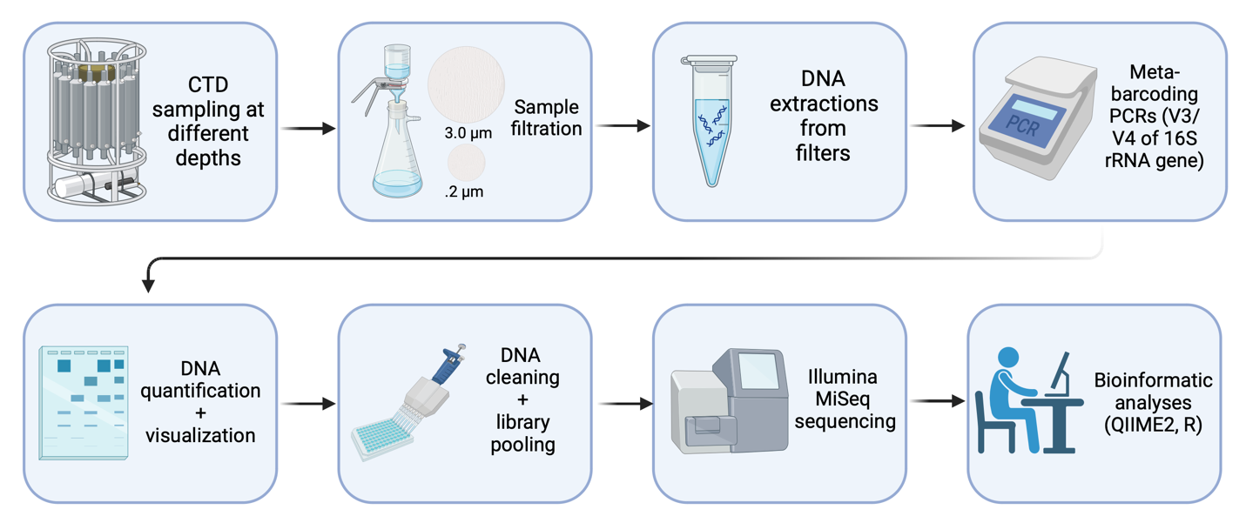

**Figure 1.** Pipeline of study.

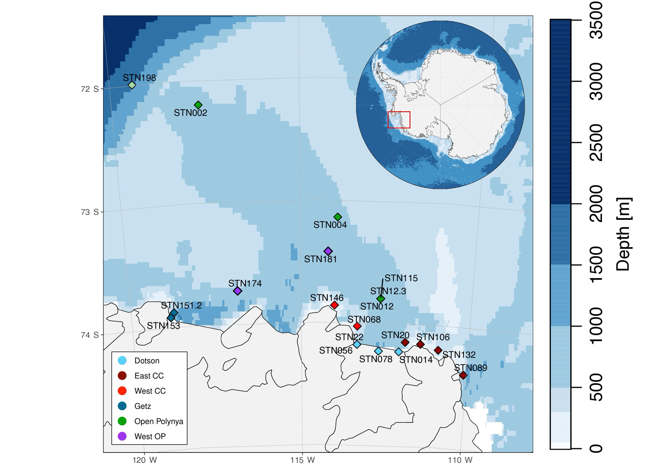

**Figure 2.** Station map with bathymetry. Colors are coordinated with location.

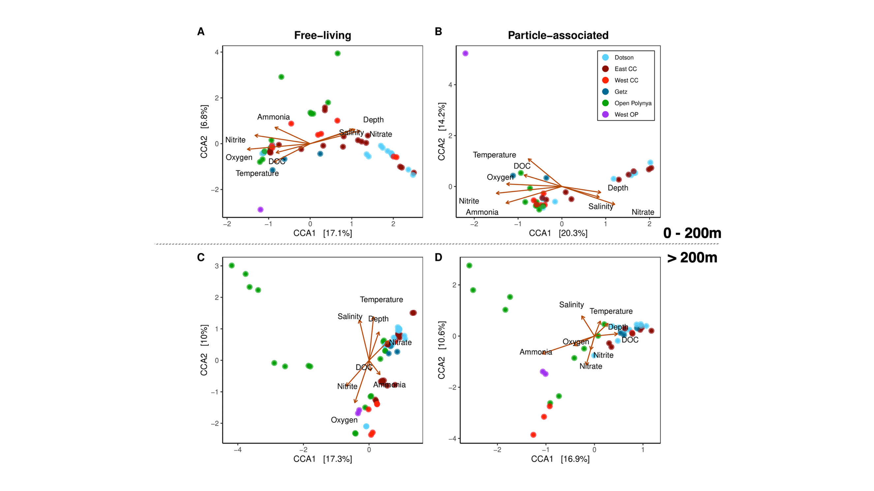

**Figure 3.** Canonical Correspondence Analysis (CCA) of free-living (**A, C**) and particle-associated (**B, D**) bacterial communities based on **location** within the ASP. First row CCAs are surface-200m and bottom row CCAs are 200m-bottom.

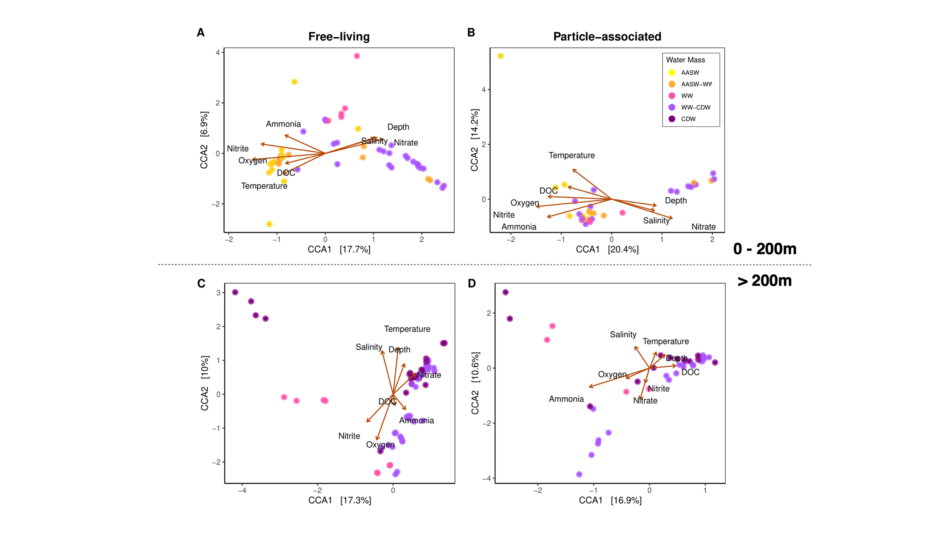

**Figure 4**. Canonical Correspondence Analysis (CCA) of free-living (**A, C**) and particle-associated (**B, D**) bacterial communities based on defined **water mass**. First row CCAs are surface-200m and bottom row CCAs are 200m-bottom.

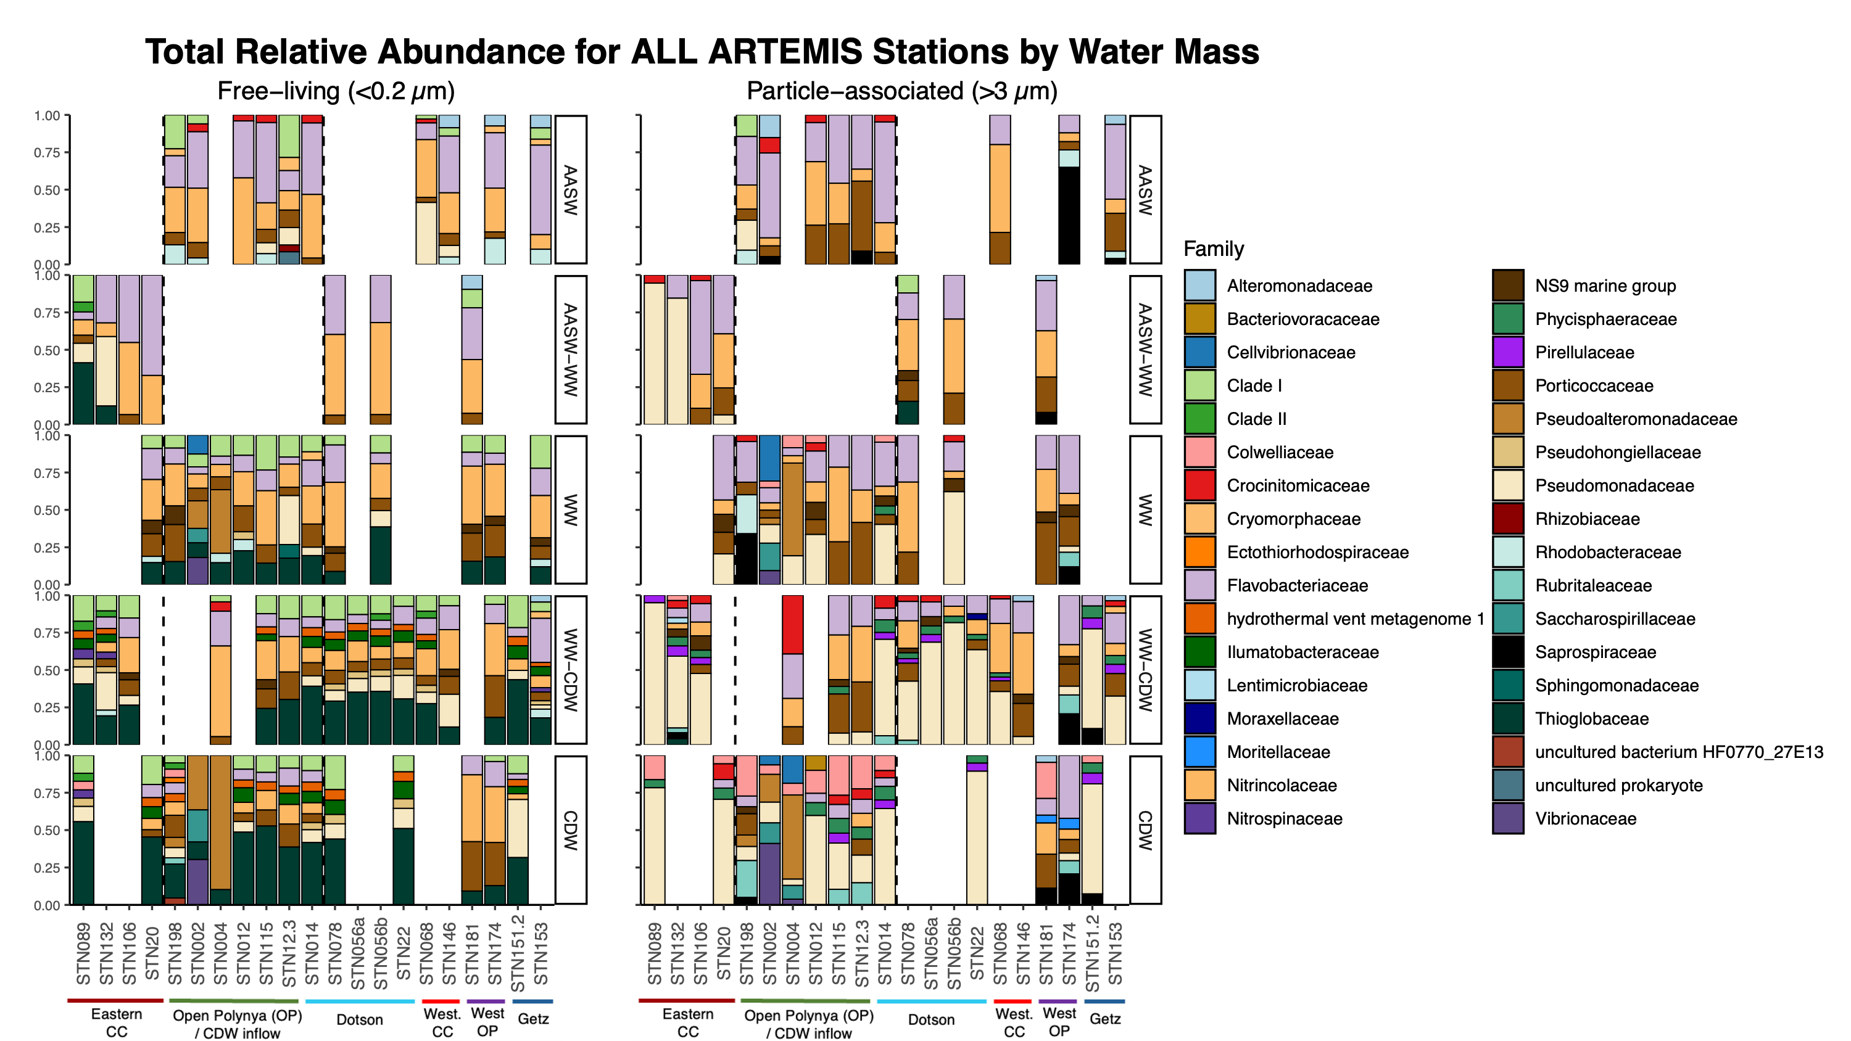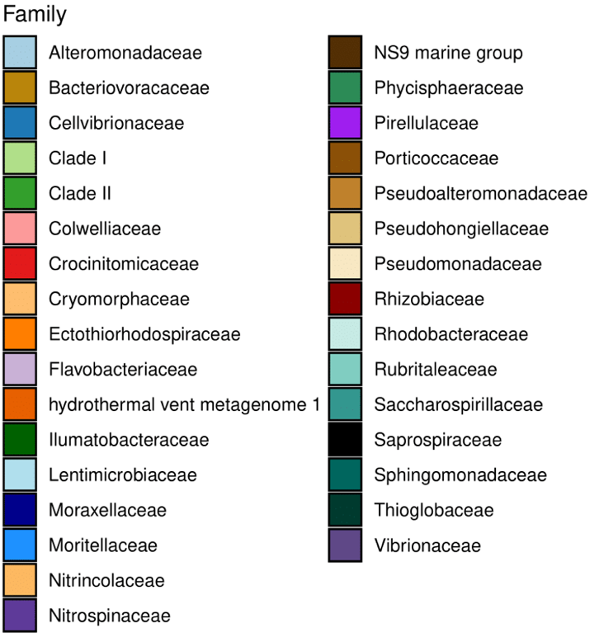

**Figure 5a.** Relative abundance for free-living (left) and particle-associated (right) communities at the family level. Each row represents a water mass, labeled on the right.

**Figure 5b.** Legend for the Family-level taxa that corresponds with Figure 5a.

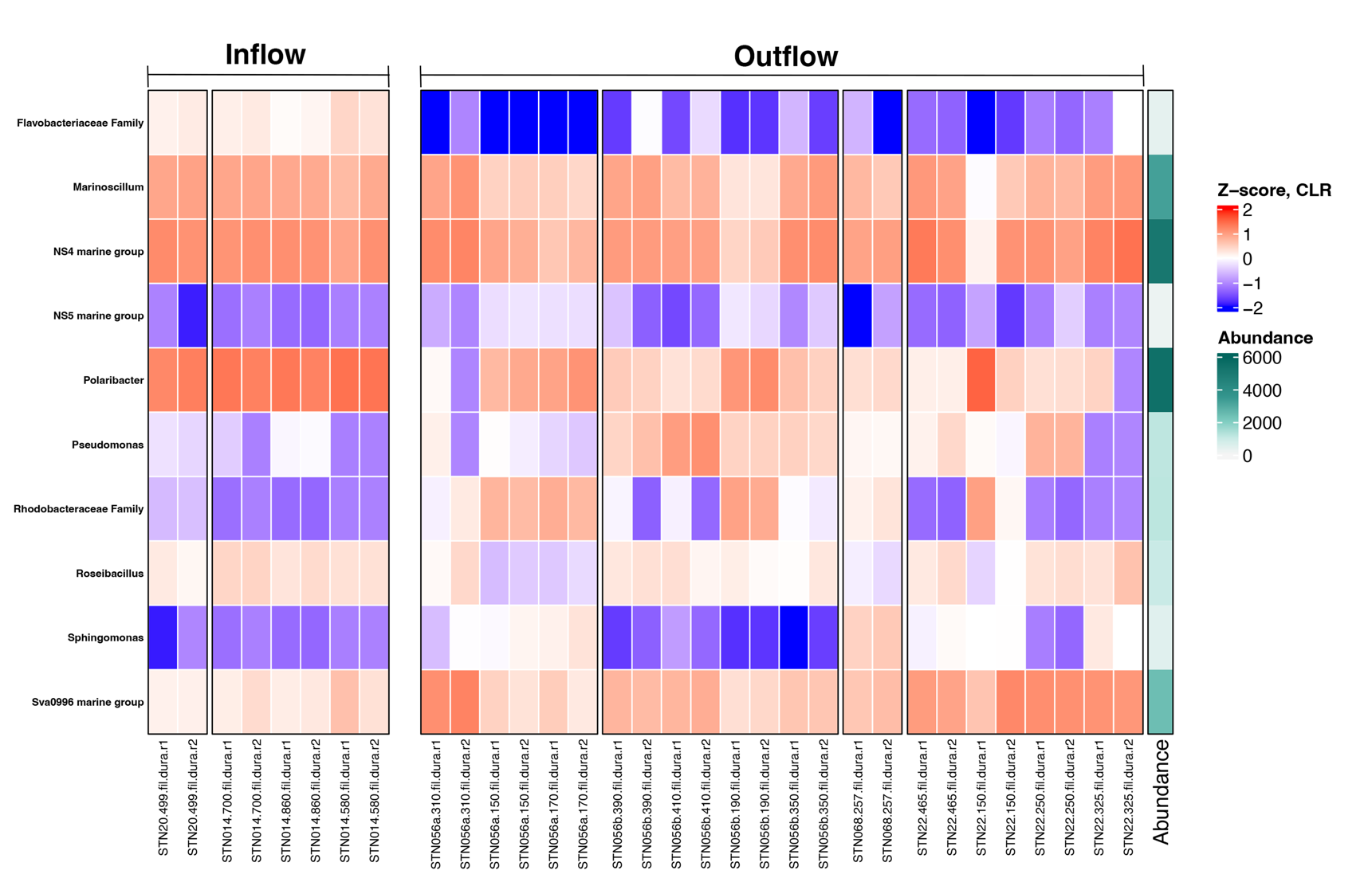

**Figure 6.** Significant **free-living** taxa from ANCOM-BC analysis for inflow vs. outflow samples. Z-score derived from log-transformed data. No significant change in particle-associated taxa from ANCOM-BC analysis.

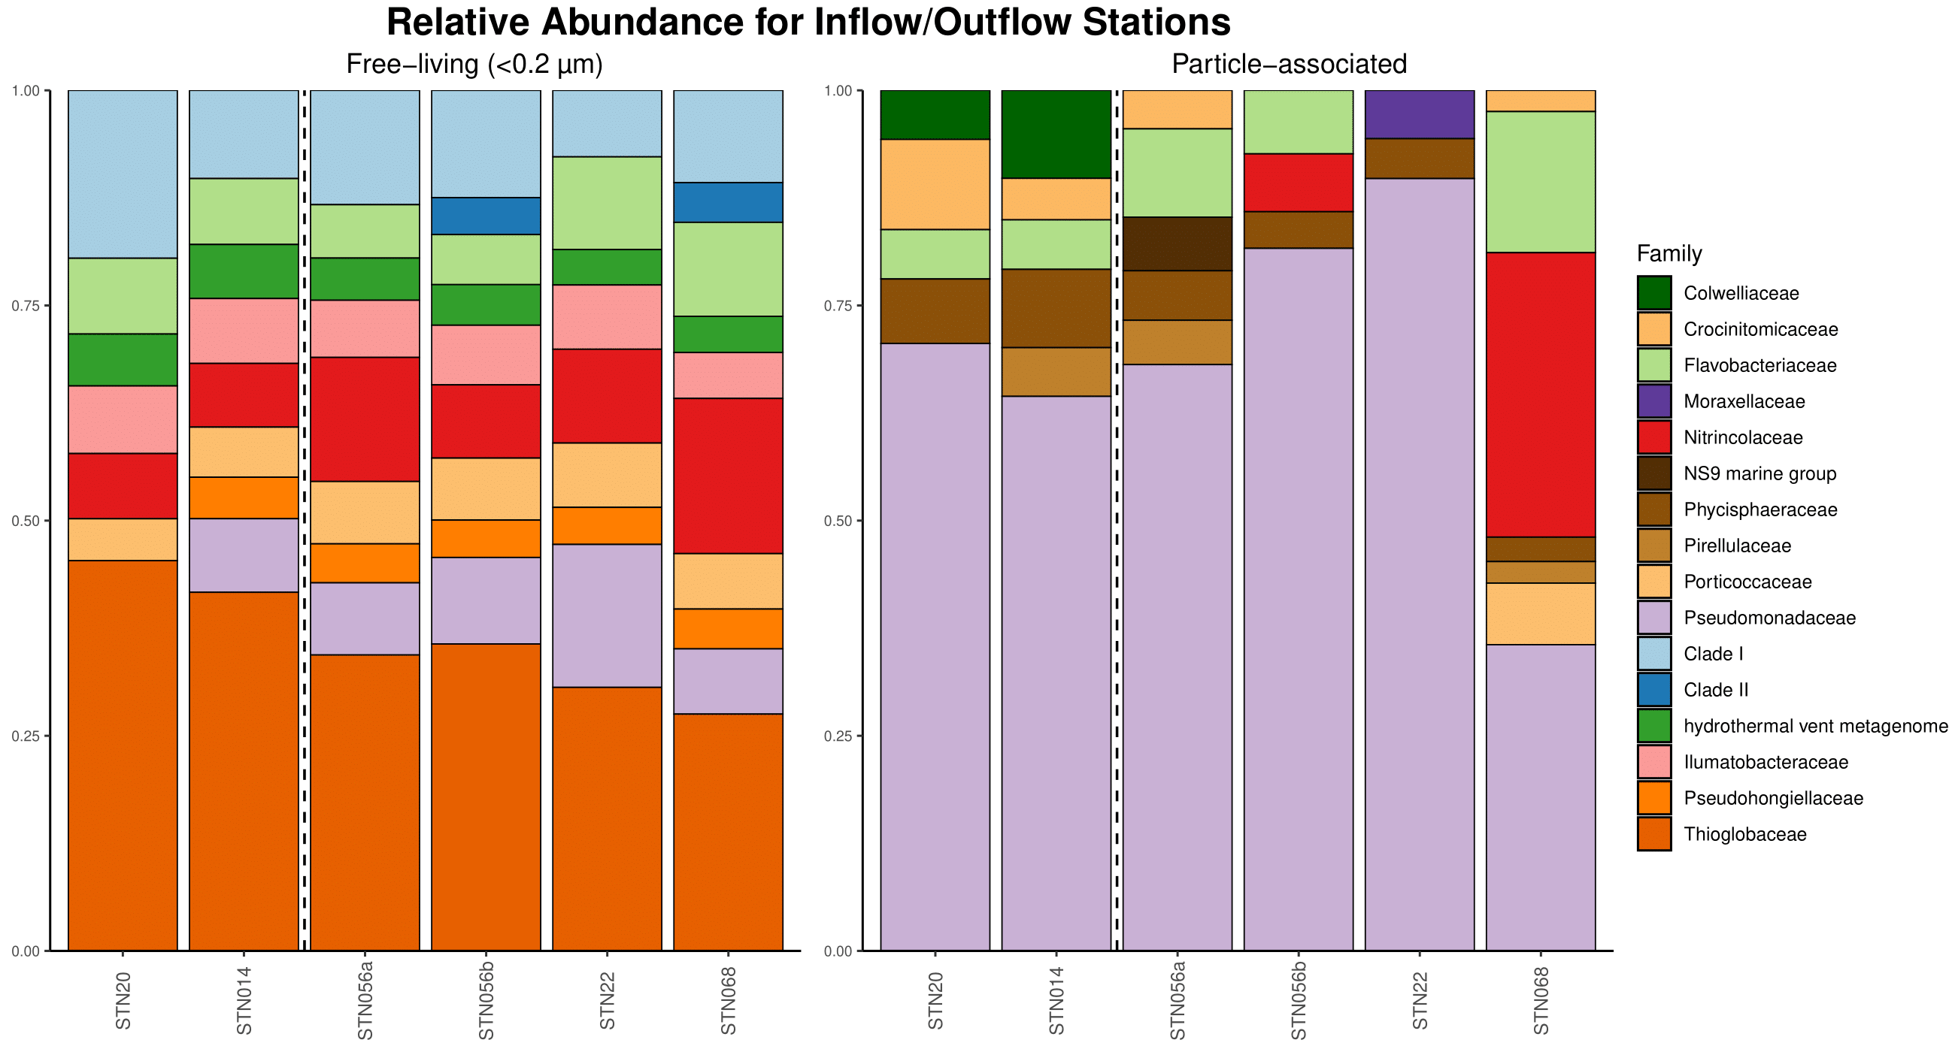

**Figure 7.** Relative abundance for free-living (left) and particle-associated (right) communities at the family level. In each community, inflow stations are before the black dashed line, while outflow are after.

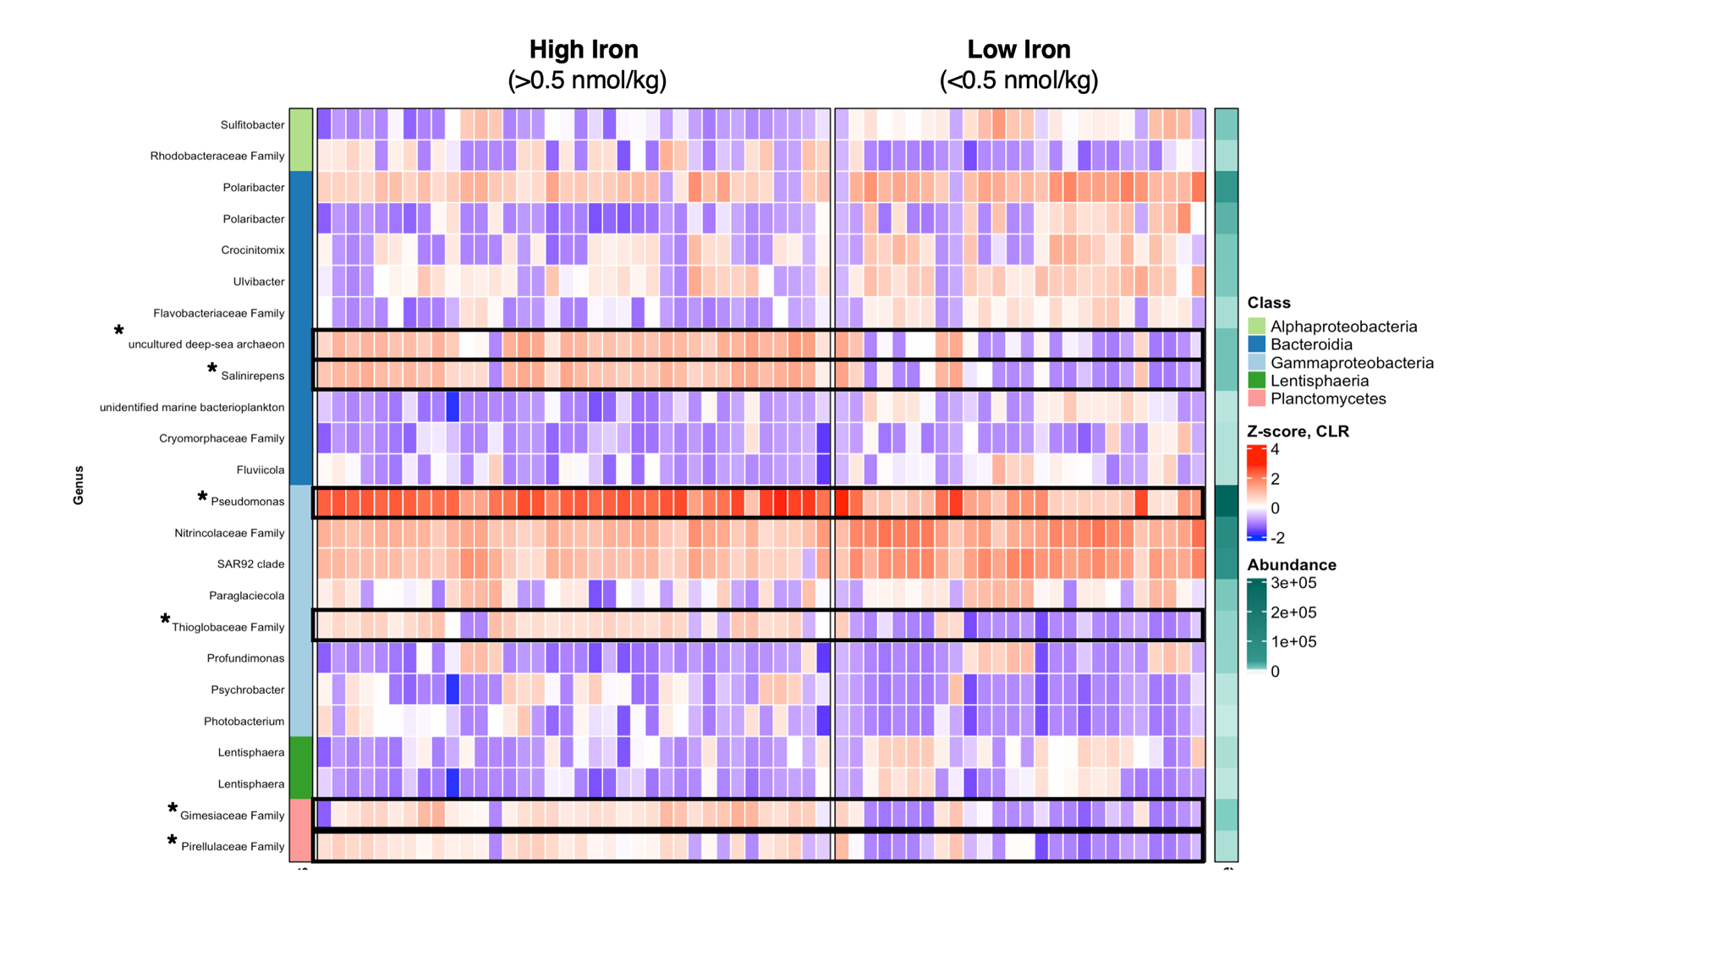

**Figure 8**. Significant **particle-associated** taxa from ANCOM-BC analysis for high (>0.5 nmol/kg) or low (<0.5 nmol/kg) dFe concentrations. Z-score derived from log-transformed data. See Supplementary Information for significant free-living taxa (**Figure S4**).

TABLES

**Table 1.** Water mass characterization with temperature and salinity ranges.

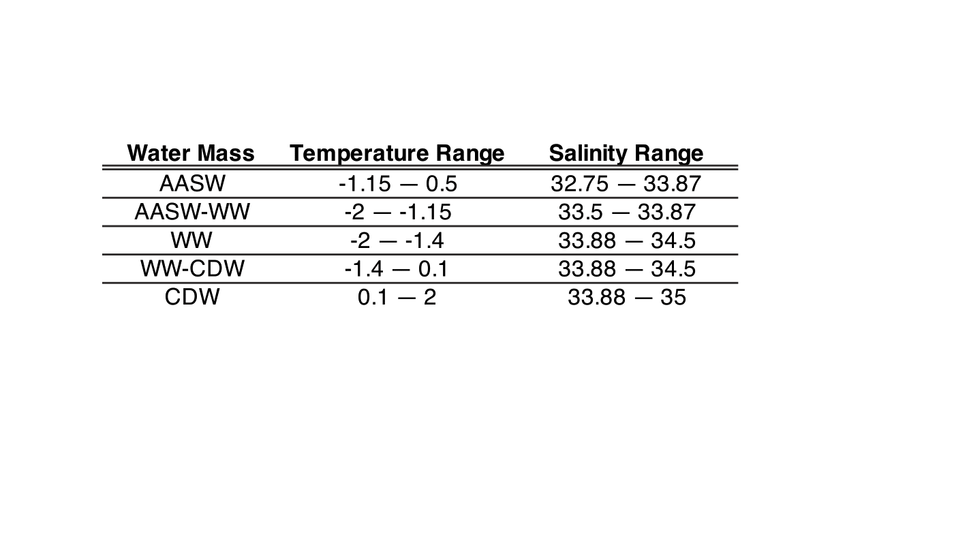

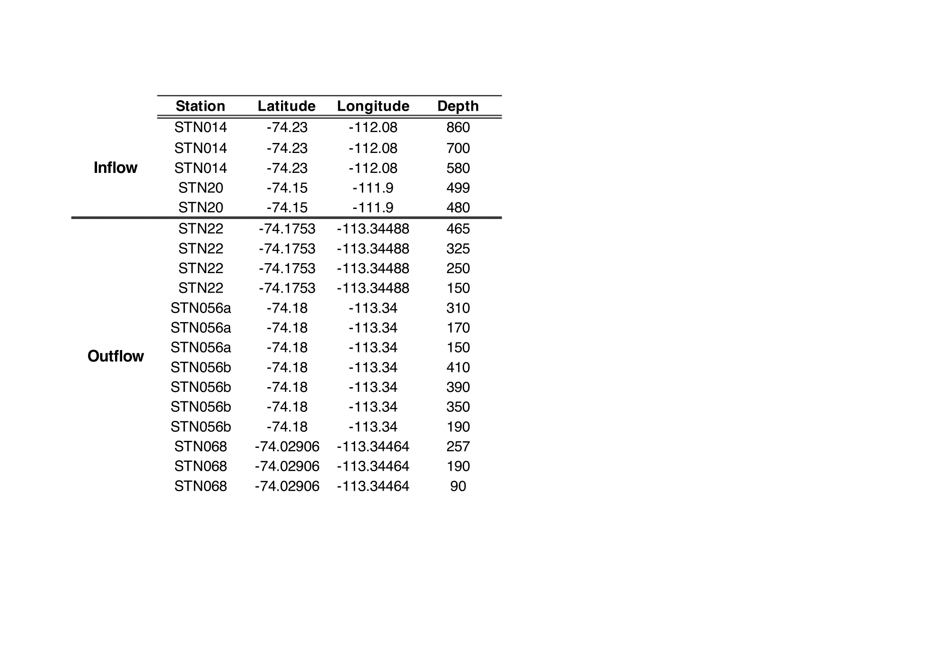

**Table 2**. Inflow and outflow stations and depth.

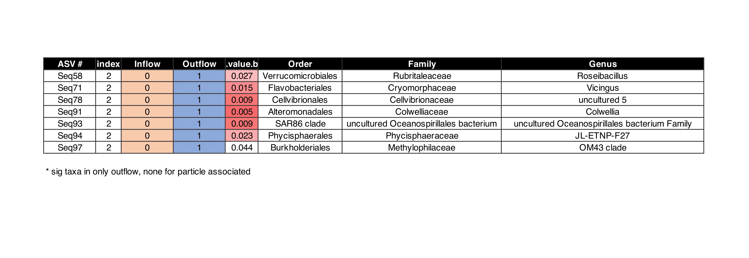

**Table 3.** Indicator species analysis of significant taxa in **free-living** outflow community. No significant indicator taxa appeared for particle-associated community.

REFERENCES

Alcamán-Arias, María Estrella, Sebastián Fuentes-Alburquenque, Pablo Vergara-Barros, Jerónimo Cifuentes-Anticevic, Josefa Verdugo, Martin Polz, Laura Farías, Carlos Pedrós-Alió, and Beatriz Díez. 2021. “Coastal Bacterial Community Response to Glacier Melting in the Western Antarctic Peninsula.” *Microorganisms* 9 (1): 1–18.

Anantharaman, Karthik, John A. Breier, Cody S. Sheik, and Gregory J. Dick. 2013. “Evidence for Hydrogen Oxidation and Metabolic Plasticity in Widespread Deep-Sea Sulfur-Oxidizing Bacteria.” *Proceedings of the National Academy of Sciences of the United States of America* 110 (1): 330–35.

Arat, Seda, George S. Bullerjahn, and Reinhard Laubenbacher. 2015. “A Network Biology Approach to Denitrification in Pseudomonas Aeruginosa.” *PloS One* 10 (2): e0118235.

Choi, Ayeon, Hyeyoun Cho, Sung-Han Kim, Bo Thamdrup, Sanghoon Lee, and Jung-Ho Hyun. 2016. “Rates of N2 Production and Diversity and Abundance of Functional Genes Associated with Denitrification and Anaerobic Ammonium Oxidation in the Sediment of the Amundsen Sea Polynya, Antarctica.” *Deep-Sea Research. Part II, Topical Studies in Oceanography* 123 (January): 113–25.

Choi, Seon-Bin, Jong-Geol Kim, Man-Young Jung, So-Jeong Kim, Ui-Gi Min, Ok-Ja Si, Soo-Je Park, et al. 2016. “Cultivation and Biochemical Characterization of Heterotrophic Bacteria Associated with Phytoplankton Bloom in the Amundsen Sea Polynya, Antarctica.” *Deep-Sea Research. Part II, Topical Studies in Oceanography* 123 (January): 126–34.

Debeljak, Pavla, Barbara Bayer, Ying Sun, Gerhard J. Herndl, and Ingrid Obernosterer. 2023. “Seasonal Patterns in Microbial Carbon and Iron Transporter Expression in the Southern Ocean.” *Microbiome* 11 (1): 187.

Delmont, Tom O., A. Murat Eren, Joseph H. Vineis, and Anton F. Post. 2015. “Genome Reconstructions Indicate the Partitioning of Ecological Functions inside a Phytoplankton Bloom in the Amundsen Sea, Antarctica.” *Frontiers in Microbiology* 6: 1090.

Delmont, Tom O., Katherine M. Hammar, Hugh W. Ducklow, Patricia L. Yager, and Anton F. Post. 2014. “Phaeocystis Antarctica Blooms Strongly Influence Bacterial Community Structures in the Amundsen Sea Polynya.” *Frontiers in Microbiology* 5 (DEC). https://doi.org/10.3389/fmicb.2014.00646.

Dinniman, Michael S., Pierre St-Laurent, Kevin R. Arrigo, Eileen E. Hofmann, and Gert L. van Dijken. 2020. “Analysis of Iron Sources in Antarctic Continental Shelf Waters.” *Journal of Geophysical Research, C: Oceans* 125 (5). https://doi.org/10.1029/2019JC015736.

———. 2023. “Sensitivity of the Relationship between Antarctic Ice Shelves and Iron Supply to Projected Changes in the Atmospheric Forcing.” *Journal of Geophysical Research, C: Oceans* 128 (2). https://doi.org/10.1029/2022jc019210.

Ducklow, Hugh W., Stephanie E. Wilson, Anton F. Post, Sharon E. Stammerjohn, Matthew Erickson, Sanghoon Lee, Kate E. Lowry, Robert M. Sherrell, and Patricia L. Yager. 2015. “Particle Flux on the Continental Shelf in the Amundsen Sea Polynya and Western Antarctic Peninsula.” *Elementa (Washington, D.C.)* 3 (January): 000046.

Gwak, Joo-Han, Samuel Imisi Awala, So-Jeong Kim, Sang-Hoon Lee, Eun-Jin Yang, Jisoo Park, Jinyoung Jung, and Sung-Keun Rhee. 2023. “Transcriptomic Insights into Archaeal Nitrification in the Amundsen Sea Polynya, Antarctica.” *Journal of Microbiology*  61 (11): 967–80.

Kharbush, Jenan J., Hilary G. Close, Benjamin A. S. Van Mooy, Carol Arnosti, Rienk H. Smittenberg, Frédéric A. C. Le Moigne, Gesine Mollenhauer, et al. 2020. “Particulate Organic Carbon Deconstructed: Molecular and Chemical Composition of Particulate Organic Carbon in the Ocean.” *Frontiers in Marine Science*. Frontiers Media S.A. https://doi.org/10.3389/fmars.2020.00518.

Kim, Chang-Sin, Tae-Wan Kim, Kyoung-Ho Cho, Ho Kyung Ha, Sanghoon Lee, Hyun-Cheol Kim, and Jae-Hak Lee. 2016. “Variability of the Antarctic Coastal Current in the Amundsen Sea.” *Estuarine, Coastal and Shelf Science* 181 (November): 123–33.

Kovalevsky, Dmitry V., Igor L. Bashmachnikov, and Genrikh V. Alekseev. 2020. “Formation and Decay of a Deep Convective Chimney.” *Ocean Modelling* 148 (April): 101583.

Martínez-Pérez, Clara, Chris Greening, Sean K. Bay, Rachael J. Lappan, Zihao Zhao, Daniele De Corte, Christina Hulbe, et al. 2022. “Phylogenetically and Functionally Diverse Microorganisms Reside under the Ross Ice Shelf.” *Nature Communications* 13 (1): 117.

Nilsson, Inge, Sten Ohlson, Lena Häggström, Nils Molin, and Klaus Mosbach. 1980. “Denitrification of Water Using Immobilized Pseudomonas Denitrificans Cells.” *European Journal of Applied Microbiology and Biotechnology* 10 (4): 261–74.

Park, Y-H, E. Charriaud, and M. Fieux. 1998. “Thermohaline Structure of the Antarctic Surface Water/Winter Water in the Indian Sector of the Southern Ocean.” *Journal of Marine Systems* 17 (1): 5–23.

Piontek, Judith, Christian Meeske, Christiane Hassenrück, Anja Engel, and Klaus Jürgens. 2022. “Organic Matter Availability Drives the Spatial Variation in the Community Composition and Activity of Antarctic Marine Bacterioplankton.” *Environmental Microbiology* 24 (9): 4030–48.

Randall-Goodwin, E., M. P. Meredith, A. Jenkins, P. L. Yager, R. M. Sherrell, E. P. Abrahamsen, R. Guerrero, et al. 2015. “Freshwater Distributions and Water Mass Structure in the Amundsen Sea Polynya Region, Antarctica.” *Elementa* 3. https://doi.org/10.12952/journal.elementa.000065.

Richert, Inga, Patricia L. Yager, Julie Dinasquet, Ramiro Logares, Lasse Riemann, Annelie Wendeberg, Stefan Bertilsson, and Douglas G. Scofield. 2019. “Summer Comes to the Southern Ocean: How Phytoplankton Shape Bacterioplankton Communities Far into the Deep Dark Sea.” *Ecosphere*  10 (3). https://doi.org/10.1002/ecs2.2641.

Schine, Casey M. S., Anne-Carlijn Alderkamp, Gert van Dijken, Loes J. A. Gerringa, Sara Sergi, Patrick Laan, Hans van Haren, Willem H. van de Poll, and Kevin R. Arrigo. 2021. “Massive Southern Ocean Phytoplankton Bloom Fed by Iron of Possible Hydrothermal Origin.” *Nature Communications* 12 (1): 1211.

Silvano, Alessandro, Stephen Rich Rintoul, Beatriz Peña-Molino, William Richard Hobbs, Esmee van Wijk, Shigeru Aoki, Takeshi Tamura, and Guy Darvall Williams. 2018. “Freshening by Glacial Meltwater Enhances Melting of Ice Shelves and Reduces Formation of Antarctic Bottom Water.” *Science Advances* 4 (4): eaap9467.

St-Laurent, P., P. L. Yager, R. M. Sherrell, S. E. Stammerjohn, and M. S. Dinniman. 2017. “Pathways and Supply of Dissolved Iron in the Amundsen Sea (Antarctica).” *Journal of Geophysical Research, C: Oceans* 122 (9): 7135–62.

Teeling, Hanno, Bernhard M. Fuchs, Dörte Becher, Christine Klockow, Antje Gardebrecht, Christin M. Bennke, Mariette Kassabgy, et al. 2012. “Substrate-Controlled Succession of Marine Bacterioplankton Populations Induced by a Phytoplankton Bloom.” *Science* 336 (6081): 608–11.

Thiele, Stefan, Julia E. Storesund, Mar Fernández-Méndez, Philipp Assmy, and Lise Øvreås. 2022. “A Winter-to-Summer Transition of Bacterial and Archaeal Communities in Arctic Sea Ice.” *Microorganisms* 10 (8). https://doi.org/10.3390/microorganisms10081618.

Thiele, Stefan, Anna Vader, Stuart Thomson, Karoline Saubrekka, Elzbieta Petelenz, Hilde Rief Armo, Oliver Müller, Lasse Olsen, Gunnar Bratbak, and Lise Øvreås. 2023. “The Summer Bacterial and Archaeal Community Composition of the Northern Barents Sea.” *Progress in Oceanography* 215 (July): 103054.

Wang, Bo, Lingfang Fan, Minfang Zheng, Yusheng Qiu, and Min Chen. 2022. “Carbon and Iron Uptake by Phytoplankton in the Amundsen Sea, Antarctica.” *Biology* 11 (12). https://doi.org/10.3390/biology11121760.

Williams, Nancy L., Richard A. Feely, Christopher L. Sabine, Andrew G. Dickson, James H. Swift, Lynne D. Talley, and Joellen L. Russell. 2015. “Quantifying Anthropogenic Carbon Inventory Changes in the Pacific Sector of the Southern Ocean.” *Marine Chemistry* 174 (August): 147–60.

Yager, Patricia. 2021. “Overview.”

SUPPLEMENTARY FIGURES

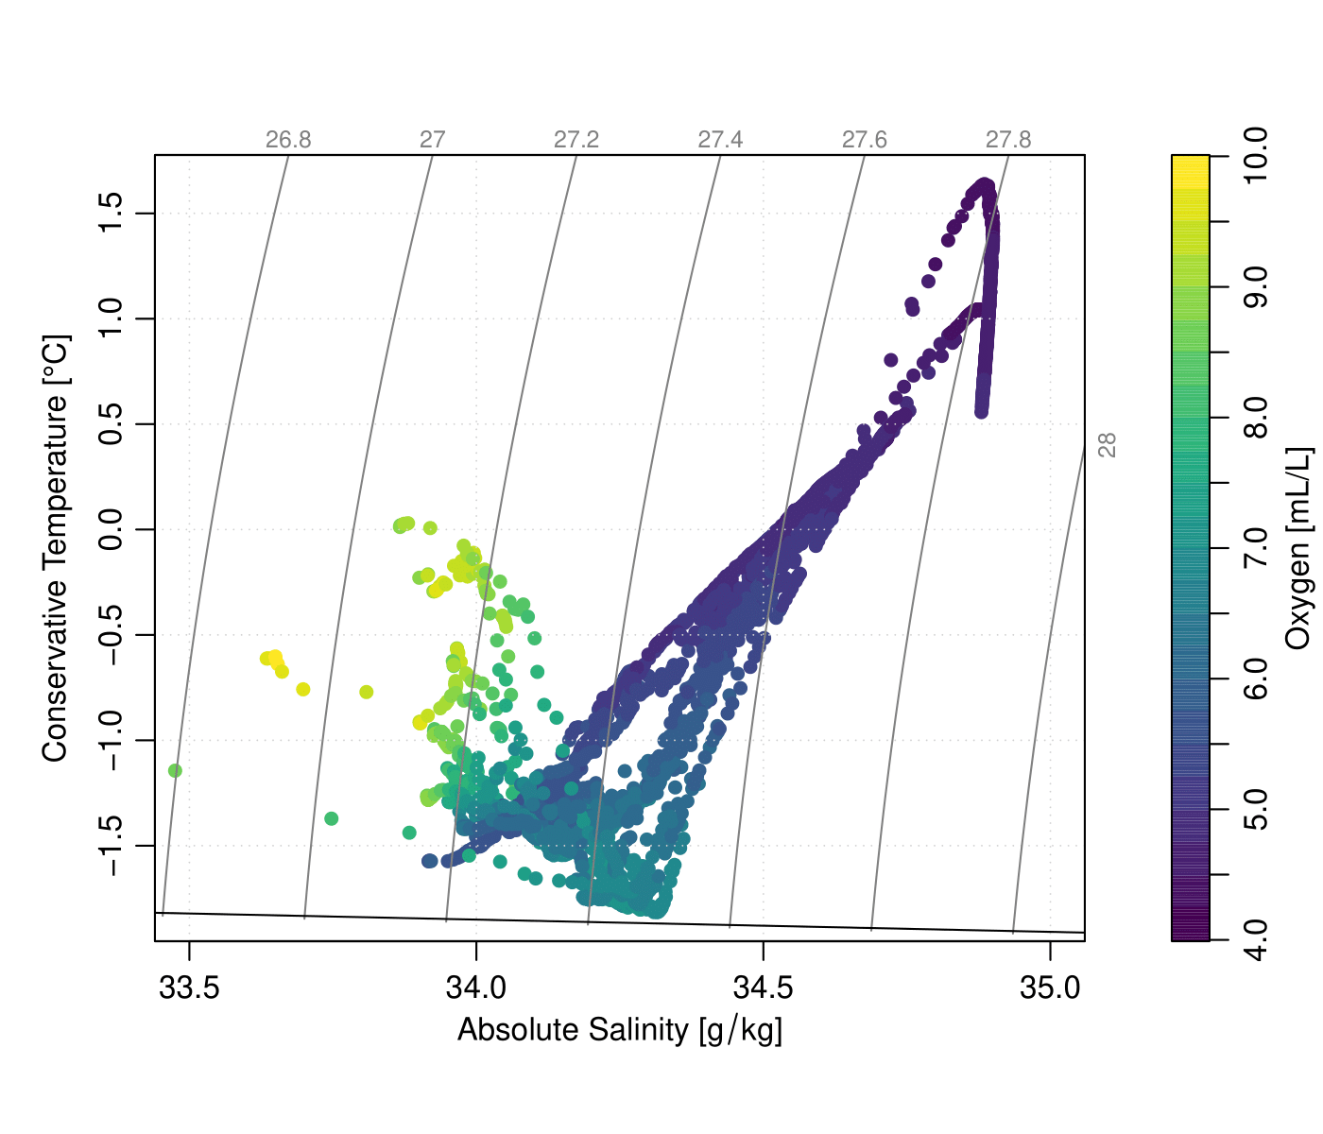

**Figure S1.** Temperature-Salinity plot for all ARTEMIS stations with DNA samples.

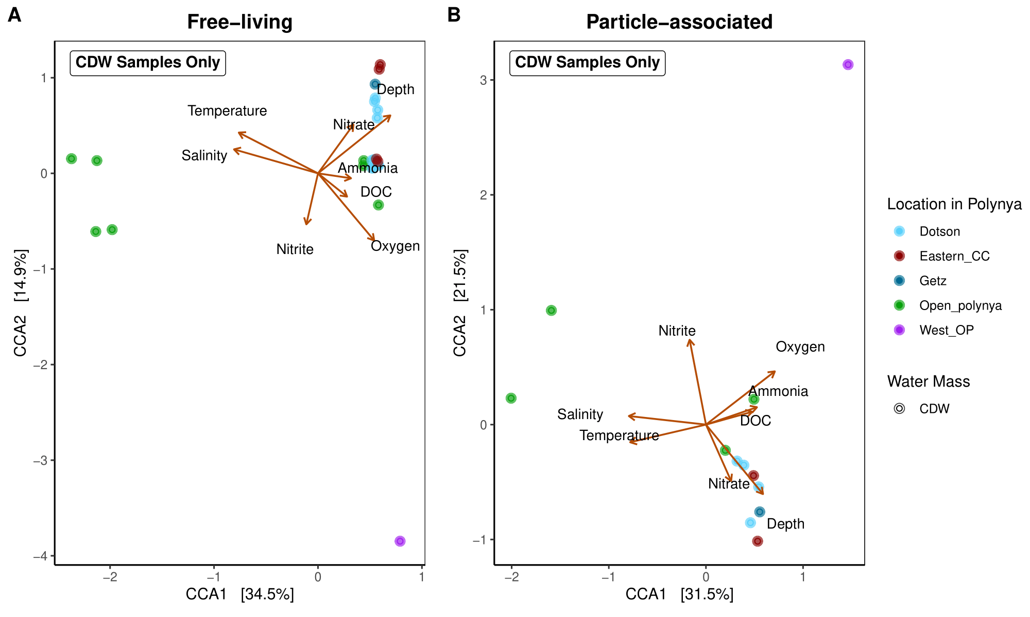

**Figure S2.** Canonical Correspondence Analysis (CCA) of free-living (**A**) and particle-associated (**B**) of samples that are characterized in CDW water mass, which are bottom water samples.

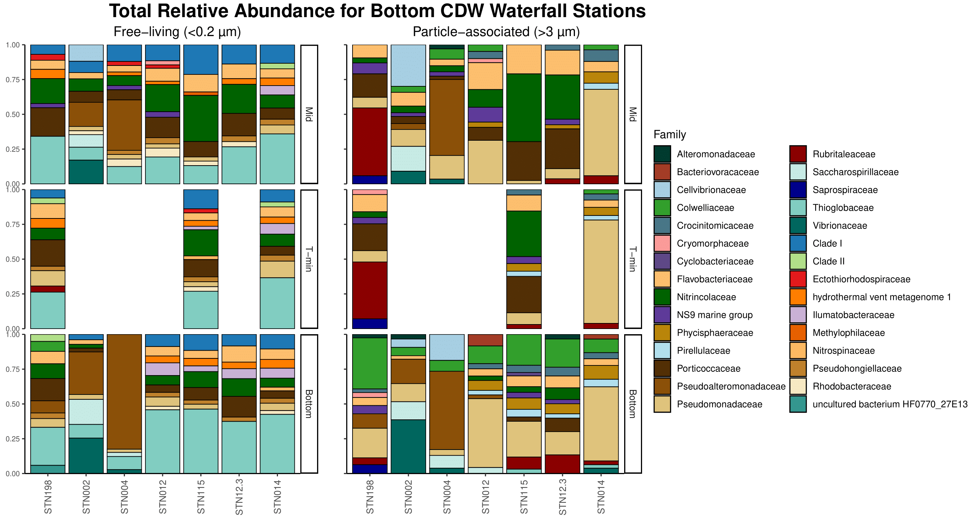

**Figure S3.** Relative abundance of stations coming from off the continental shelf at the family level. Free-living on left and particle-associated on the right.

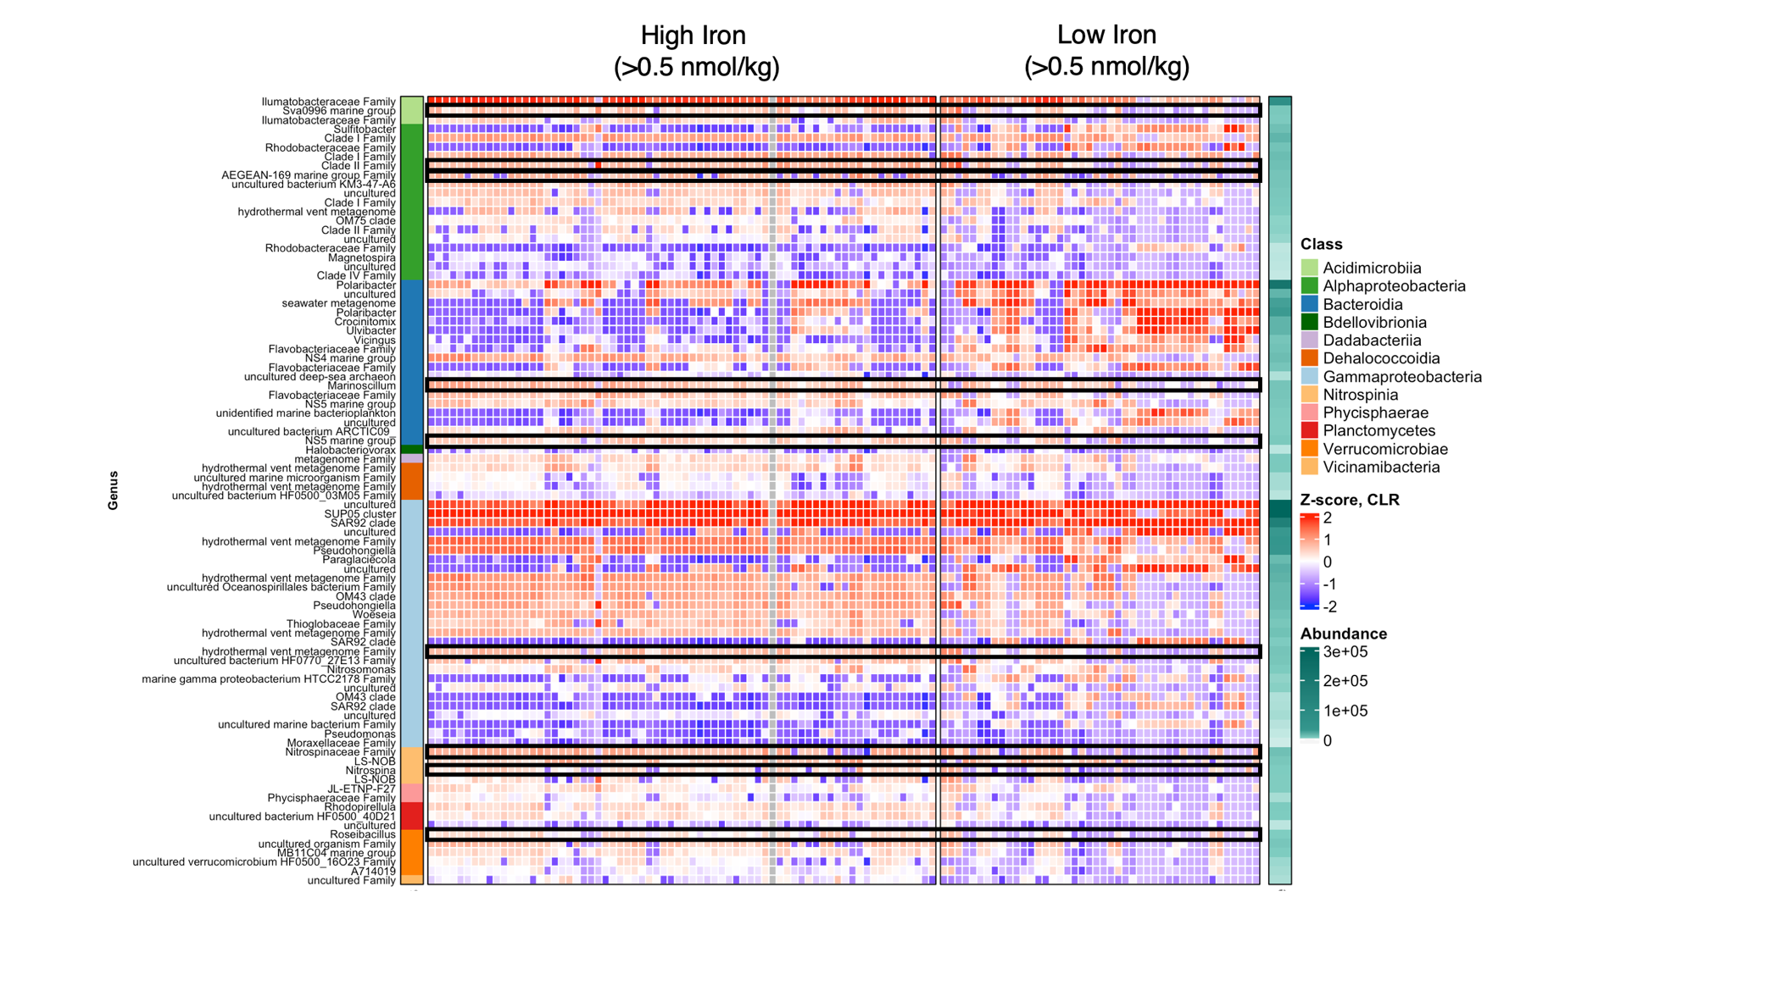

**Figure S4**. Significant **free-living** taxa from ANCOM-BC analysis for high (>0.5 nmol/kg) or low (<0.5 nmol/kg) dFe concentrations. Z-score derived from log-transformed data.

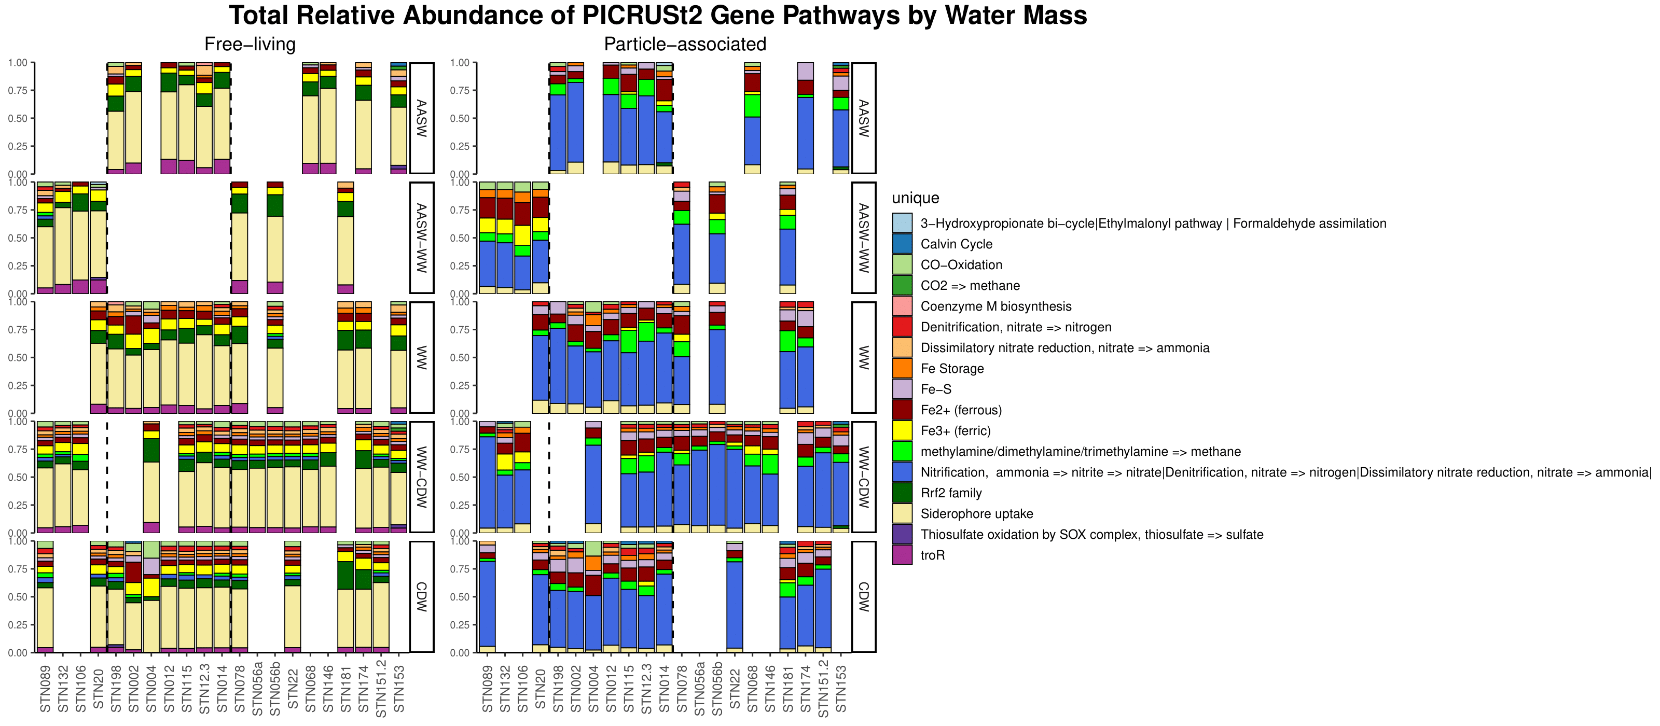

**Figure S5a**. Relative abundance of PICRUSt2 KO numbers by water mass and station. Free-living on left and particle-associated on the right.



**Figure S5b.** Legend that corresponds to **Figure S5a.**

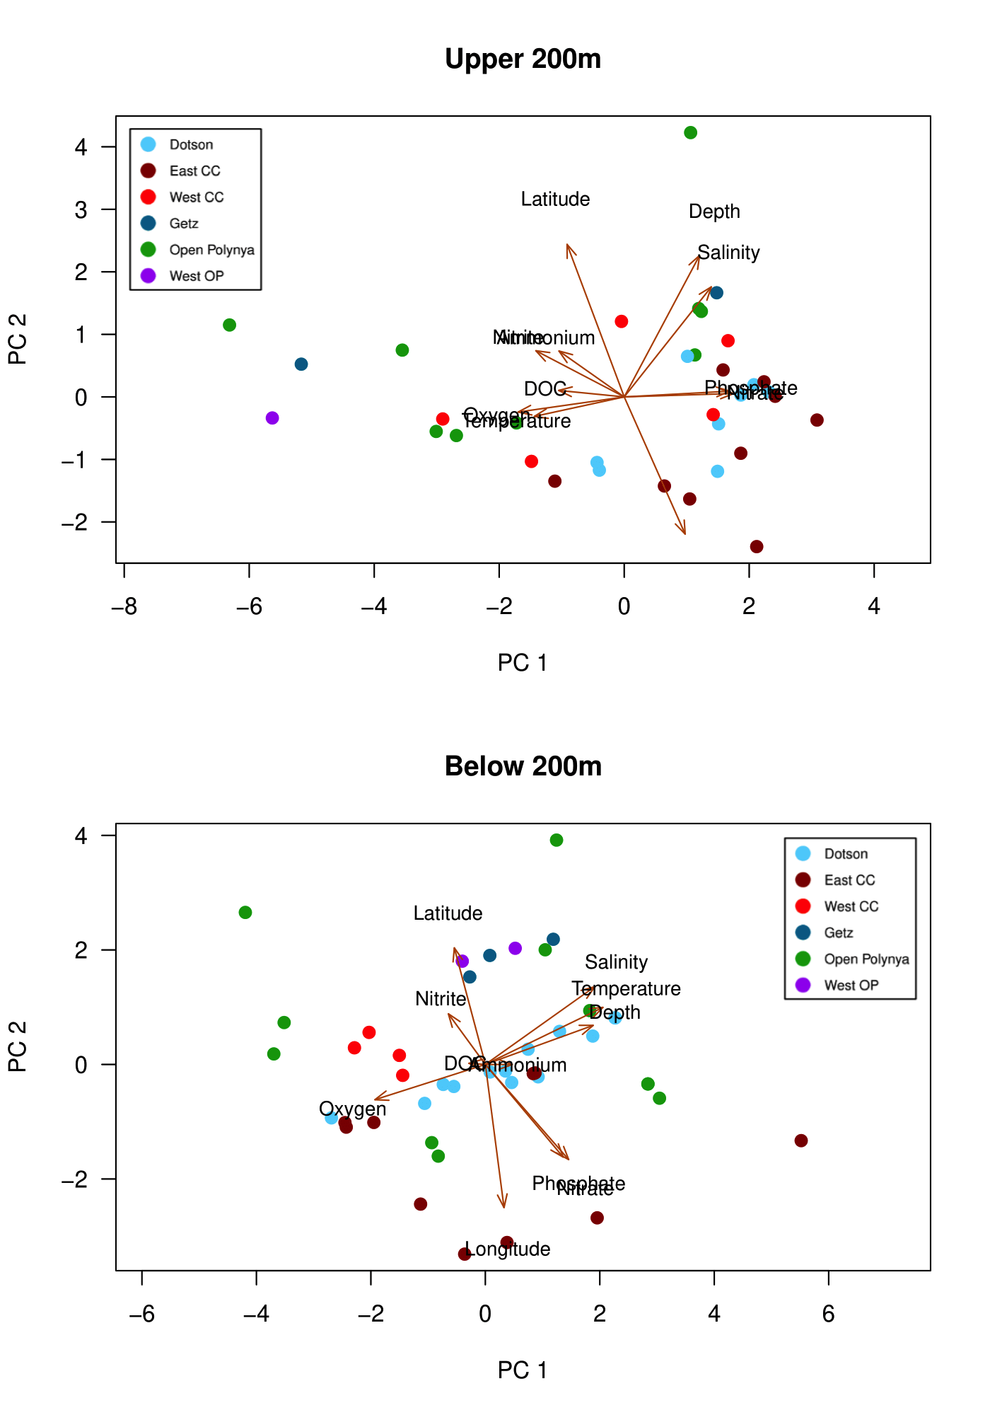

**Figure S6.** PCA of sample metadata by location in the ASP. Top PCA is surface-200m and bottom PCA is 200-bottom.

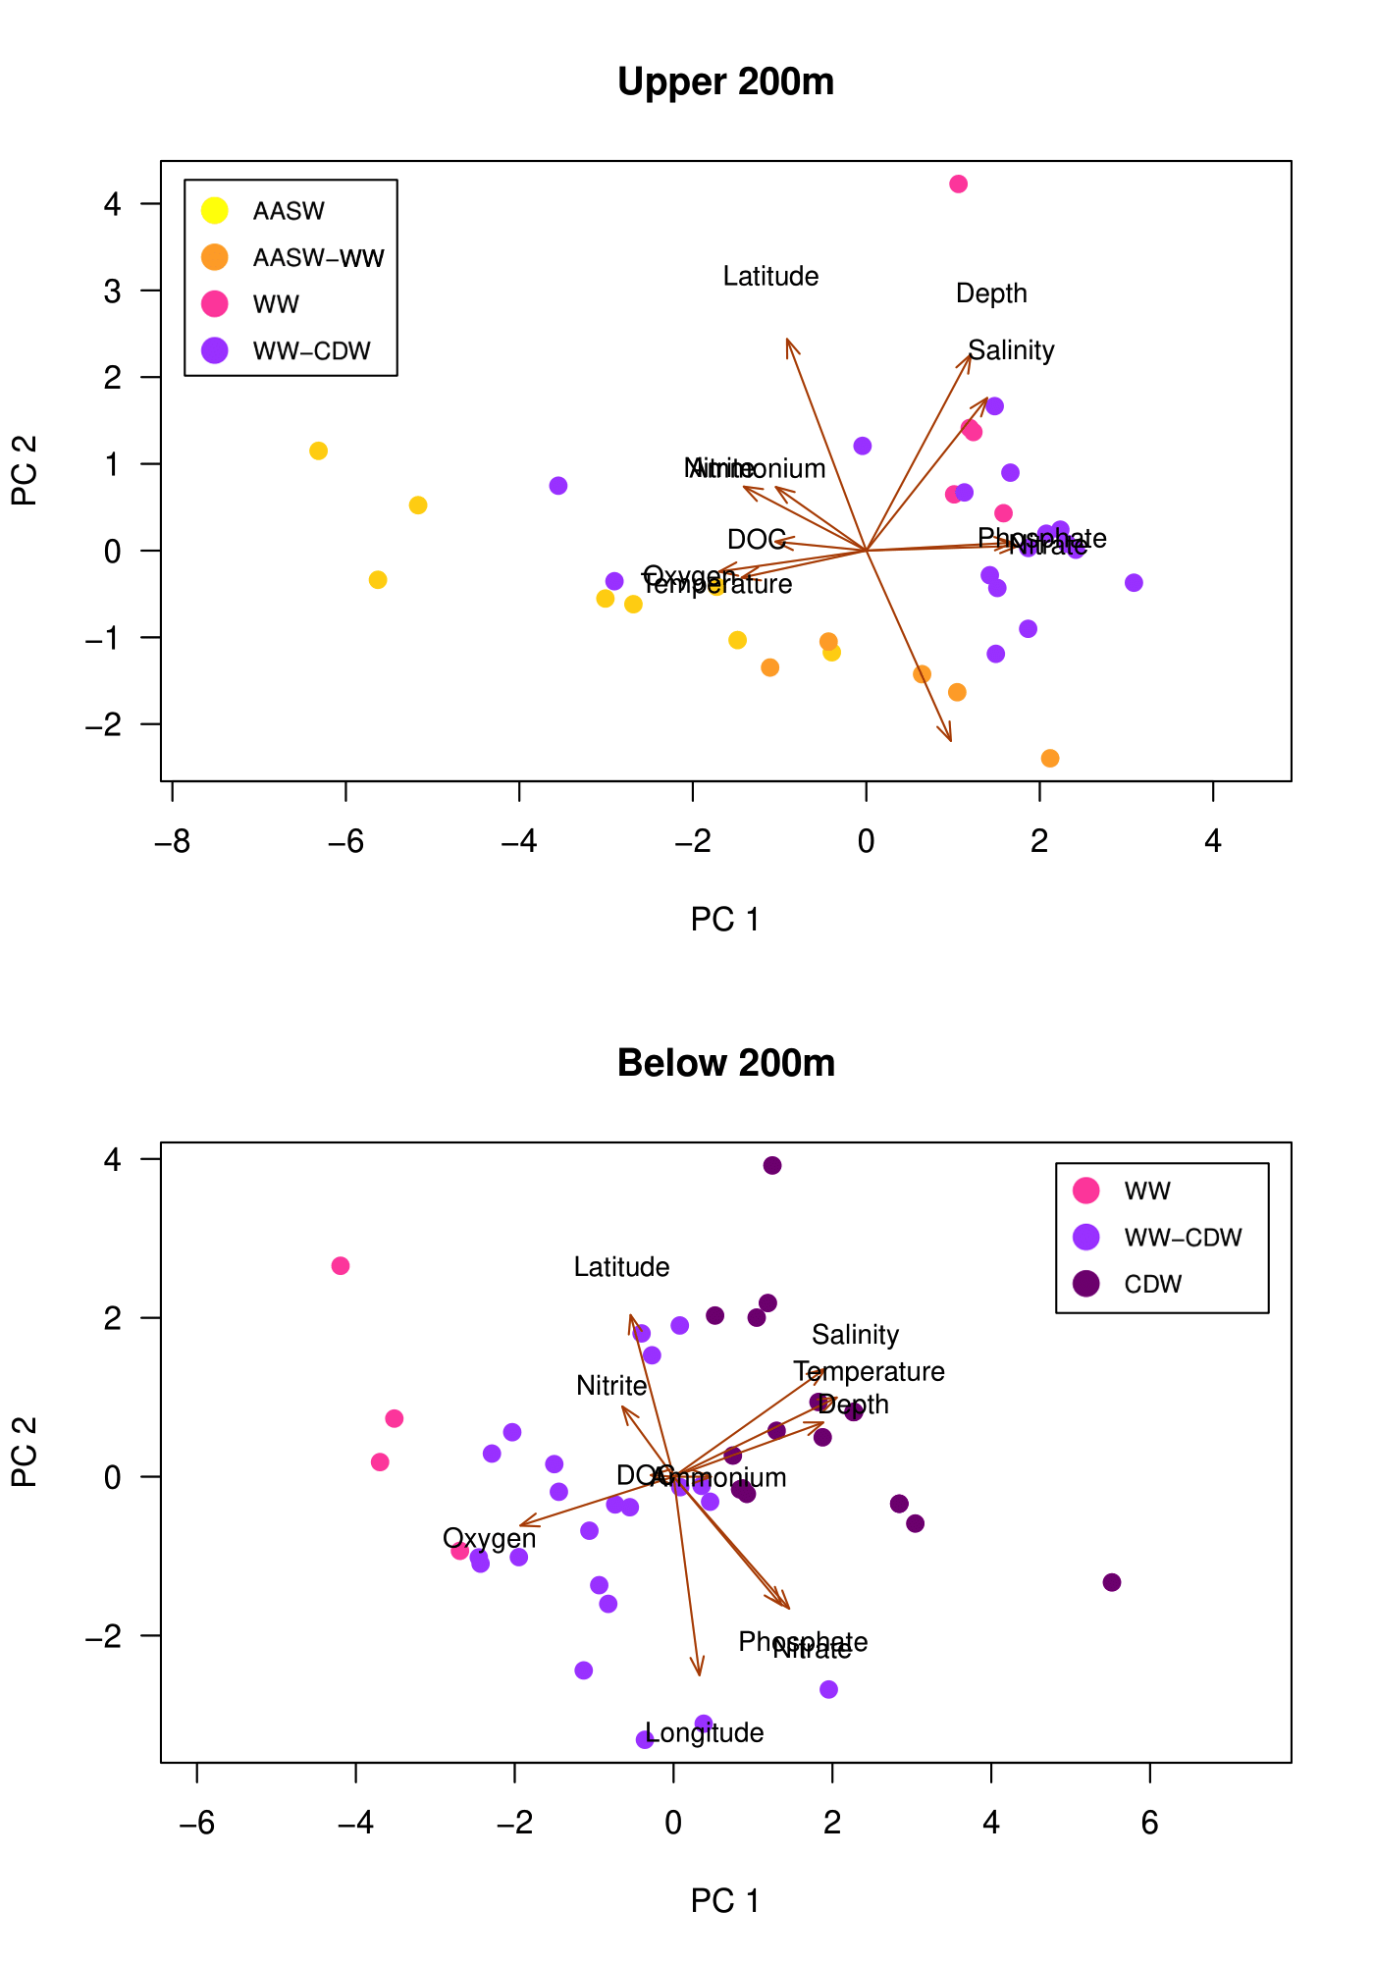

**Figure S7**. PCA of sample metadata by water mass in the ASP. Top PCA is surface-200m and bottom PCA is 200-bottom.



**Figure S8**. Relative abundance by water mass and station at the Family level, including Archaea. Similar to previous relative abundance plot, but includes prevalence of *Nitrosopumilaceae*, a known ammonia-oxidizing archaea.

SUPPLEMENTARY TABLES

**Table S1.** Nutrient ranges for all stations combined.

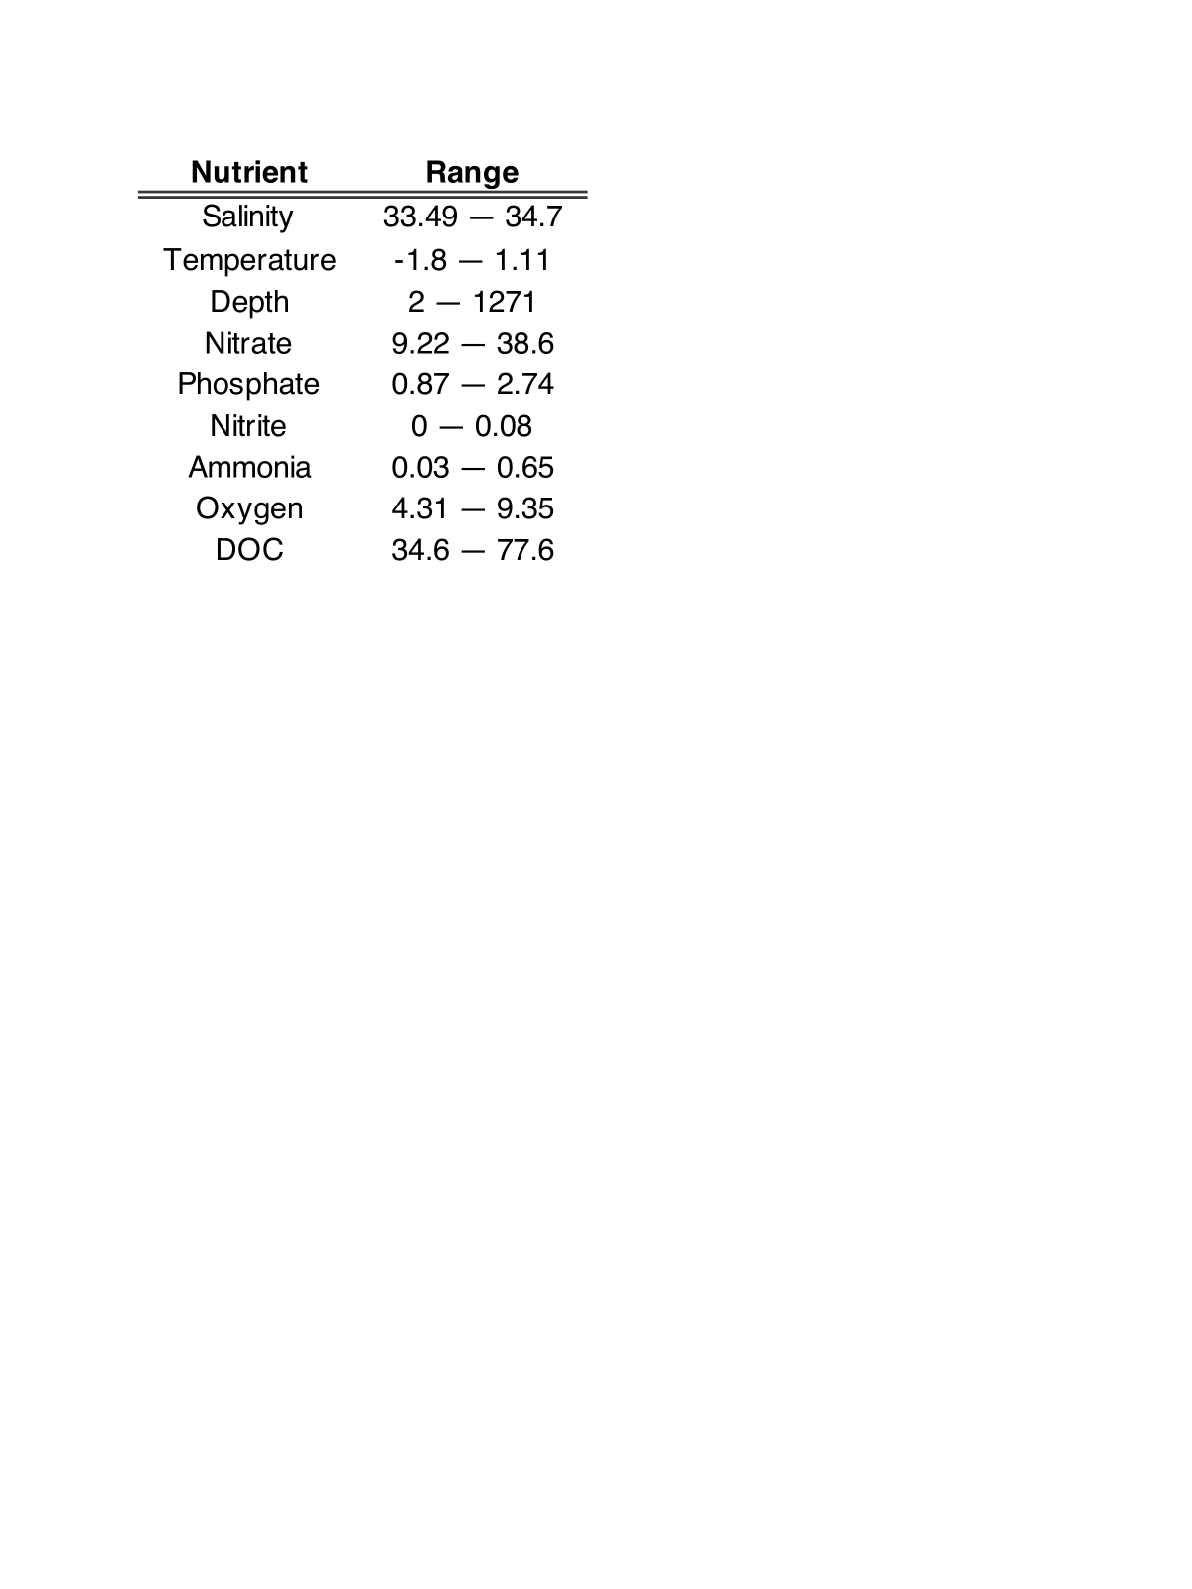

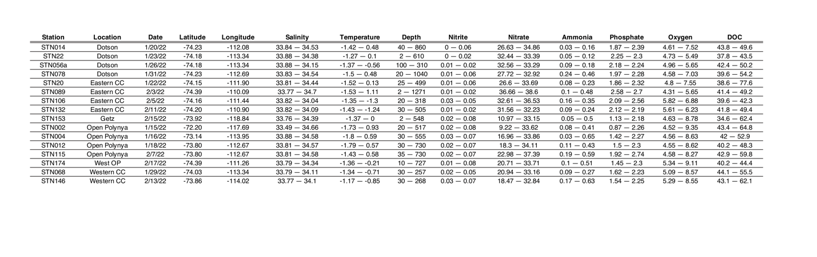

**Table S2.** Nutrient ranges per station.

**Table S3.** Indicator species for **free-living** communities based on location, separated into surface-200m (upper 200m) and 200-bottom (below 200m).

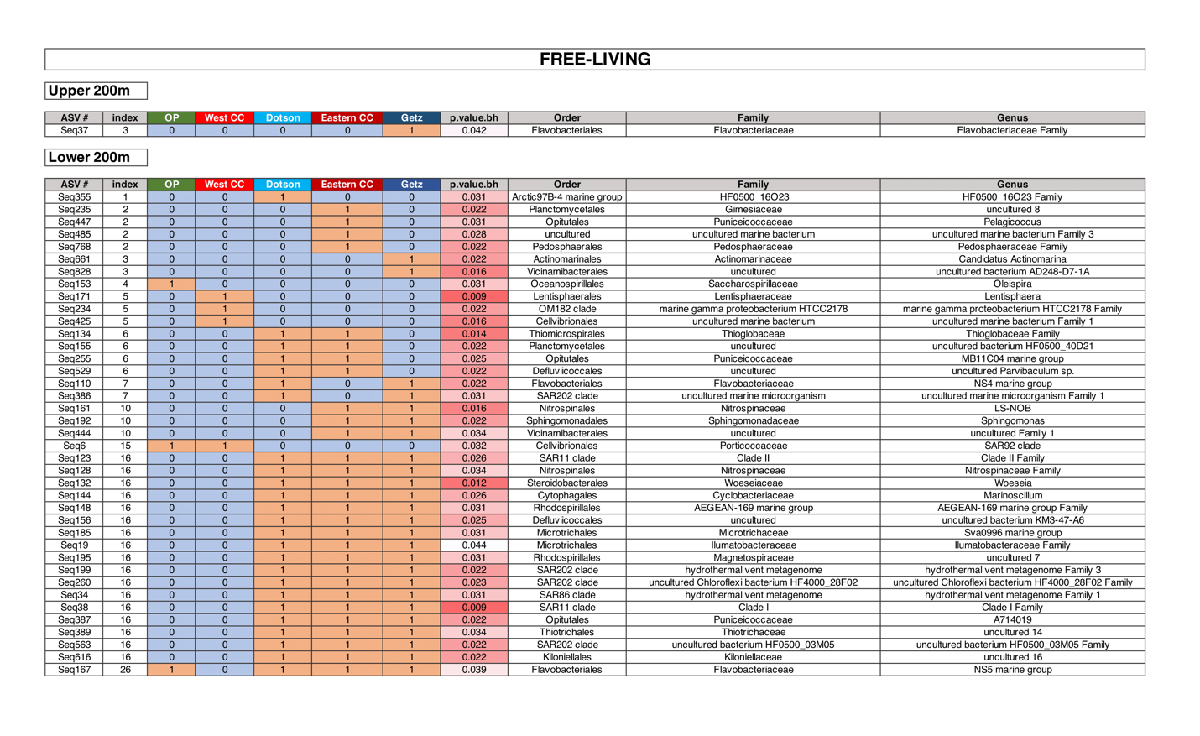

**Table S4.** Indicator species for **particle-associated** communities based on location, separated into surface-200m (upper 200m) and 200-bottom (below 200m). No significant taxa for upper 200m.

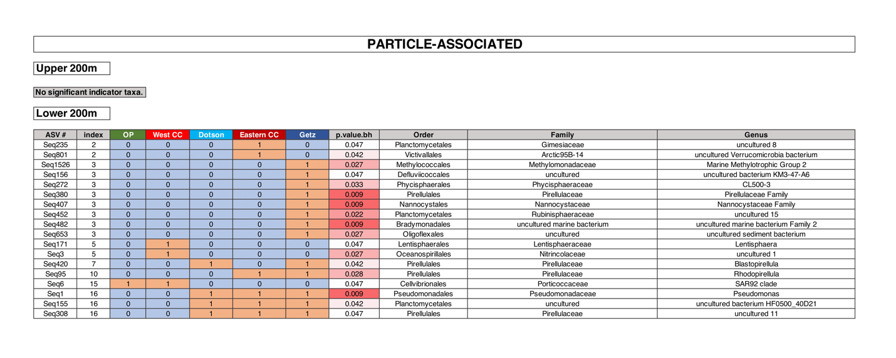

**Table S5.** Indicator species for **free-living** communities based on location for CDW samples ONLY.

